BLOODY VOICE
Art Prompts: Weapon Modules, Creatures and Icons
20 modules in 11 cell shapes · 8 creatures × 4 images · 152 icons
Prompts for ChatGPT image generation, built from the game data

How to use this document
- One chat per set: one chat for all modules, one chat per creature, one chat per icon style. The model keeps the style inside a chat.
- Always paste the STYLE BLOCK first (plus the MODULE STYLE or ICON STYLE the prompt names), then the prompt.
- Attach the files named in the prompt: templates from docs/assets/templates/, references from art/ui/ and assets/ui/.
- When a result is good, attach it as a style reference for the next one.
- Save with the exact file name, then run the import (section C).
The prompts are generated from data/gear/*.json and data/monsters/*.json. When the data changes, rebuild this file: python tools/art_prompts/refs.py then node tools/art_prompts/build.js.

Contents
How to use this document 1
A. Weapon Modules 3
A.1 What a module is 3
A.2 Shapes and templates 3
A.3 Cell types and materials 4
A.4 Style references to attach 4
A.5 Module catalog 4
A.6 Prompts, one per module 5
B. Creature Silhouettes and Combat Art 10
B.1 Four images per creature 10
B.2 Rules 10
B.3 Templates and references 10
B.4 Prompts, four per creature 11
D. Game Icons 18
D.1 Four icon styles 18
D.2 How icon sheets work 18
D.3 Icon catalog and prompts 18
C. After Generation 32
C.1 Import 32
C.2 Quality checklist 32

A. Weapon Modules

A.1 What a module is
A module is a part installed into the cells of a weapon section (sight, magazine, stock, frame, barrel). Its art must have the exact shape of its cells, because the player places it on the weapon tablet like a puzzle piece. The game rotates modules, so draw each one in its base orientation (as in the template).
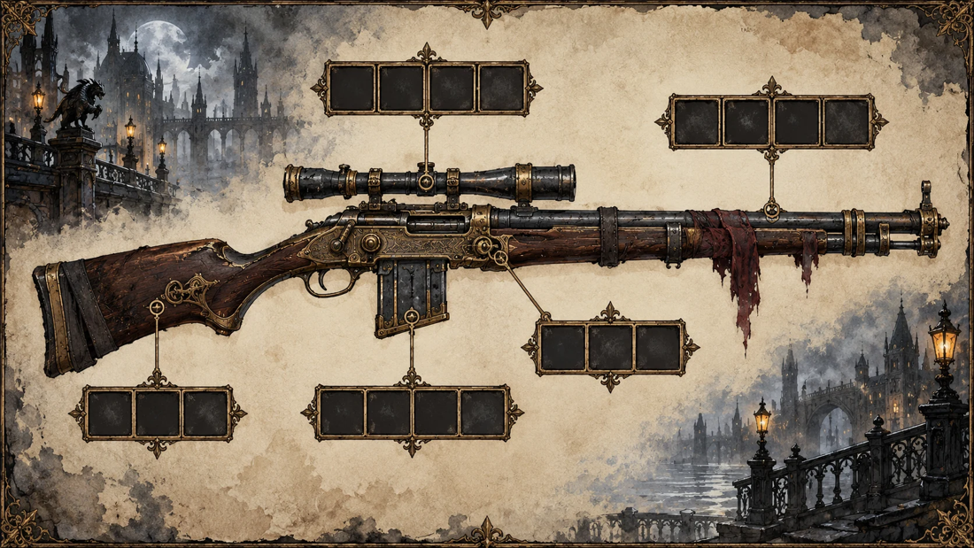
Reference — the weapon tablet the modules are installed into (art/ui/WEAPON__tablet.webp)

A.2 Shapes and templates
Every shape is made of square cells. One cell = 256×256 px in the game. The templates are in docs/assets/templates/modules/ — attach the one named in the prompt (SHAPE__T4.png etc.). The dark area is the part; the dashed inner line is the safe zone for important details.
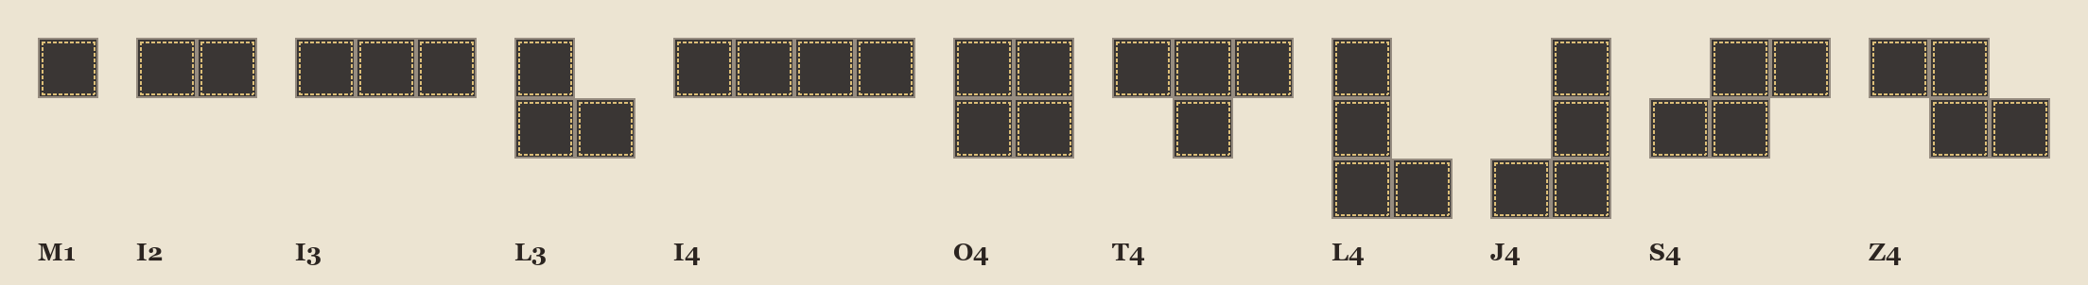
All module shapes (docs/assets/templates/modules/shapes_overview.png)
Shape | Cells | Description | Game size | Ask ChatGPT for
M1 | 1 | a single square cell | 256×256 | 1:1 (1024×1024)
I2 | 2 | two cells side by side (a 2×1 bar) | 512×256 | 3:2 landscape (1536×1024)
I3 | 3 | three cells in a row (a 3×1 bar) | 768×256 | 3:2 landscape (1536×1024)
L3 | 3 | a corner of three cells: one on top, two below (left one under it) | 512×512 | 1:1 (1024×1024)
I4 | 4 | four cells in a row (a 4×1 bar) | 1024×256 | 3:2 landscape (1536×1024)
O4 | 4 | a 2×2 square of four cells | 512×512 | 1:1 (1024×1024)
T4 | 4 | a T of four cells: three in a row on top, one under the middle | 768×512 | 3:2 landscape (1536×1024)
L4 | 4 | an L of four cells: three stacked vertically, one to the right of the bottom cell | 512×768 | 2:3 portrait (1024×1536)
J4 | 4 | a J of four cells: three stacked vertically, one to the left of the bottom cell | 512×768 | 2:3 portrait (1024×1536)
S4 | 4 | an S of four cells: two on top shifted right, two below shifted left | 768×512 | 3:2 landscape (1536×1024)
Z4 | 4 | a Z of four cells: two on top shifted left, two below shifted right | 768×512 | 3:2 landscape (1536×1024)
Why the sizes differ: ChatGPT can only output 1:1, 3:2 or 2:3 images. That is fine: tools/import_art.py scales every module to its exact size and cuts away everything outside its cells automatically. Just keep the part centred and filling the shape.

A.3 Cell types and materials
The cell type tells which cells of the weapon a module fits into, and it must be readable from the art at a glance:
Cell type | Materials and colour | Unlocked by
GEAR (mechanical) | brass, blued steel, rivets, springs, warm gold highlights, no glow | Start (Mechanic web)
SPARK (electric) | copper coils, glass, porcelain insulators, a cold blue glow (#6FA8FF) and thin electric arcs | Mechanic web
BLOOD (beast) | bone, sinew, leather, glass vials with dark red ichor, organic shapes, a faint red glow | Monster web (the Voice)

A.4 Style references to attach
Attach the resource icons sheet as the item style reference (same ink outline, same painted metal):
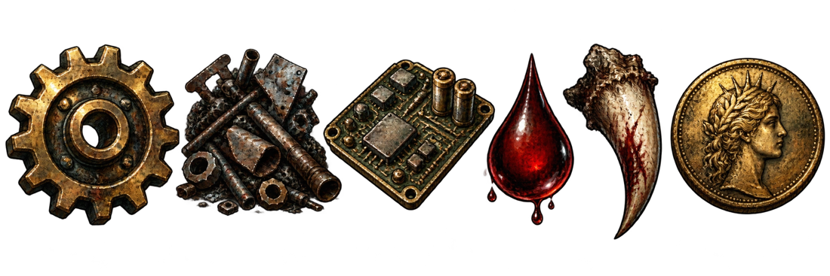
Style reference — resource icons (assets/ui/RESOURCES__six_icons.png)
STYLE BLOCK (paste at the start of every prompt):
Dark gaslight-and-steel fantasy, Lovecraftian mysticism. Hand-painted illustration
with ink linework, like an old engraved plate coloured with muted watercolour.
Palette: soot black #2B2420, parchment #ECE4D2, tarnished brass #B08A4A,
cold steel blue #6E7A8A, dried blood red #8A1C1C, fog grey #BDBDB8,
sickly moon silver #C9CCD8. Low saturation, strong value contrast.
Late-19th-century craftsmanship fused with advanced machinery (brass, rivets, glass).
No text, no letters, no numbers, no watermarks, no modern objects, no neon, no anime style.
MODULE STYLE (after the style block):
A single weapon part seen from directly above (top-down, orthographic, no perspective),
as if laid flat on a workbench. Same rendering as the attached resource icons:
thick dark ink outline, painted metal with scratches and wear, warm light from the top-left.
Transparent background. No table, no frame, no grid, no cell borders, no shadow outside the part.

A.5 Module catalog
Module | Section | Shape | Cell | Effect in game
Harpoon Launcher | barrel | I3 | gear | Adds card: Harpoon Shot.
Rifled Barrel | barrel | I4 | gear | Shots deal +2 damage.
Coil Accelerator | barrel | I2 | spark | Next to a Harpoon Launcher: Harpoon Shot becomes Shock Harpoon.
Flame Nozzle | barrel | L3 | spark | Adds card: Gout of Flame.
Net Caster | barrel | I3 | gear | On capture contracts adds card: Iron Net.
Brass Scope | sight | I2 | gear | Shots at body parts deal +3 damage.
Lantern Lens | sight | M1 | spark | Adds card: Flash.
Eye of the Hound | sight | M1 | blood | Start of the fight: see the creature's next moves.
Drum Magazine | magazine | O4 | gear | +2 max ammo.
Quick Loader | magazine | I2 | gear | Reload also draws 1 more card.
Ichor Cartridges | magazine | L3 | blood | Shots apply 1 Bleed.
Capacitor Bank | magazine | T4 | spark | Adds card: Overcharge.
Recoil Spring | stock | S4 | gear | Shots also give 2 block.
Bayonet Mount | stock | L4 | gear | Adds card: Bayonet Thrust.
Bone Brace | stock | Z4 | blood | Rage cards cost 1 less HP.
Gyro Stabilizer | frame | T4 | gear | First turn: draw 1 more card.
Galvanic Core | frame | O4 | spark | First turn: +1 AP.
Vein Lattice | frame | I4 | blood | Blood modules touching it get a stronger effect.
Serrated Rail | frame | J4 | gear | Adds card: Serrated Edge.
Smoke Vent | frame | L4 | gear | Adds card: Smoke Screen.

A.6 Prompts, one per module
File name: assets/modules/<MODULE_ID>__module__normal.png (upper-case id, e.g. CAPACITOR_BANK__module__normal.png).

Harpoon Launcher [HARPOON_LAUNCHER · I3 · gear]
[STYLE BLOCK]
[MODULE STYLE]
Attached: SHAPE__I3.png (exact shape of the part), RESOURCE icons (style reference),
WEAPON__tablet (the rifle these parts are installed into).
Weapon module "Harpoon Launcher" for a monster hunter's rifle — barrel section.
Cell type GEAR (mechanical): brass, blued steel, rivets, springs, warm gold highlights, no glow.
The part: a short brass harpoon-gun barrel with a barbed steel harpoon loaded in it and a coiled chain wrapped along the side.
SHAPE I3: three cells in a row (a 3×1 bar) — 3×1 cells.
Make the part fill the dark area of the attached template edge to edge, following its outline;
keep the important details inside the dashed inner lines. Everything outside the shape is transparent.
Do not draw the template's grid or dashed lines.
Output: transparent PNG, aspect 3:2 landscape (1536×1024).

Rifled Barrel [RIFLED_BARREL · I4 · gear]
[STYLE BLOCK]
[MODULE STYLE]
Attached: SHAPE__I4.png (exact shape of the part), RESOURCE icons (style reference),
WEAPON__tablet (the rifle these parts are installed into).
Weapon module "Rifled Barrel" for a monster hunter's rifle — barrel section.
Cell type GEAR (mechanical): brass, blued steel, rivets, springs, warm gold highlights, no glow.
The part: a long blued-steel barrel with brass bands and small cut-away windows showing spiral rifling inside.
SHAPE I4: four cells in a row (a 4×1 bar) — 4×1 cells.
Make the part fill the dark area of the attached template edge to edge, following its outline;
keep the important details inside the dashed inner lines. Everything outside the shape is transparent.
Do not draw the template's grid or dashed lines.
Output: transparent PNG, aspect 3:2 landscape (1536×1024).

Coil Accelerator [COIL_ACCELERATOR · I2 · spark]
[STYLE BLOCK]
[MODULE STYLE]
Attached: SHAPE__I2.png (exact shape of the part), RESOURCE icons (style reference),
WEAPON__tablet (the rifle these parts are installed into).
Weapon module "Coil Accelerator" for a monster hunter's rifle — barrel section.
Cell type SPARK (electric): copper coils, glass, porcelain insulators, a cold blue glow (#6FA8FF) and thin electric arcs.
The part: a short tube wrapped in stacked copper coil rings, thin blue electric arcs jumping between the rings.
SHAPE I2: two cells side by side (a 2×1 bar) — 2×1 cells.
Make the part fill the dark area of the attached template edge to edge, following its outline;
keep the important details inside the dashed inner lines. Everything outside the shape is transparent.
Do not draw the template's grid or dashed lines.
Output: transparent PNG, aspect 3:2 landscape (1536×1024).

Flame Nozzle [FLAME_NOZZLE · L3 · spark]
[STYLE BLOCK]
[MODULE STYLE]
Attached: SHAPE__L3.png (exact shape of the part), RESOURCE icons (style reference),
WEAPON__tablet (the rifle these parts are installed into).
Weapon module "Flame Nozzle" for a monster hunter's rifle — barrel section.
Cell type SPARK (electric): copper coils, glass, porcelain insulators, a cold blue glow (#6FA8FF) and thin electric arcs.
The part: an angled heat-blued nozzle with a tiny pilot flame, a small round fuel tank and a spark igniter with a blue glow.
SHAPE L3: a corner of three cells: one on top, two below (left one under it) — 2×2 cells.
Make the part fill the dark area of the attached template edge to edge, following its outline;
keep the important details inside the dashed inner lines. Everything outside the shape is transparent.
Do not draw the template's grid or dashed lines.
Output: transparent PNG, aspect 1:1 (1024×1024).

Net Caster [NET_CASTER · I3 · gear]
[STYLE BLOCK]
[MODULE STYLE]
Attached: SHAPE__I3.png (exact shape of the part), RESOURCE icons (style reference),
WEAPON__tablet (the rifle these parts are installed into).
Weapon module "Net Caster" for a monster hunter's rifle — barrel section.
Cell type GEAR (mechanical): brass, blued steel, rivets, springs, warm gold highlights, no glow.
The part: a wide-mouthed launcher tube with a folded iron-wire net and small lead weights sticking out of its mouth.
SHAPE I3: three cells in a row (a 3×1 bar) — 3×1 cells.
Make the part fill the dark area of the attached template edge to edge, following its outline;
keep the important details inside the dashed inner lines. Everything outside the shape is transparent.
Do not draw the template's grid or dashed lines.
Output: transparent PNG, aspect 3:2 landscape (1536×1024).

Brass Scope [BRASS_SCOPE · I2 · gear]
[STYLE BLOCK]
[MODULE STYLE]
Attached: SHAPE__I2.png (exact shape of the part), RESOURCE icons (style reference),
WEAPON__tablet (the rifle these parts are installed into).
Weapon module "Brass Scope" for a monster hunter's rifle — sight section.
Cell type GEAR (mechanical): brass, blued steel, rivets, springs, warm gold highlights, no glow.
The part: a long brass telescopic sight with adjustment knobs and a lens that faintly shows a crosshair.
SHAPE I2: two cells side by side (a 2×1 bar) — 2×1 cells.
Make the part fill the dark area of the attached template edge to edge, following its outline;
keep the important details inside the dashed inner lines. Everything outside the shape is transparent.
Do not draw the template's grid or dashed lines.
Output: transparent PNG, aspect 3:2 landscape (1536×1024).

Lantern Lens [LANTERN_LENS · M1 · spark]
[STYLE BLOCK]
[MODULE STYLE]
Attached: SHAPE__M1.png (exact shape of the part), RESOURCE icons (style reference),
WEAPON__tablet (the rifle these parts are installed into).
Weapon module "Lantern Lens" for a monster hunter's rifle — sight section.
Cell type SPARK (electric): copper coils, glass, porcelain insulators, a cold blue glow (#6FA8FF) and thin electric arcs.
The part: a small round lens in a brass ring with a tiny caged electric bulb glowing behind it.
SHAPE M1: a single square cell — 1×1 cells.
Make the part fill the dark area of the attached template edge to edge, following its outline;
keep the important details inside the dashed inner lines. Everything outside the shape is transparent.
Do not draw the template's grid or dashed lines.
Output: transparent PNG, aspect 1:1 (1024×1024).

Eye of the Hound [HOUND_EYE · M1 · blood]
[STYLE BLOCK]
[MODULE STYLE]
Attached: SHAPE__M1.png (exact shape of the part), RESOURCE icons (style reference),
WEAPON__tablet (the rifle these parts are installed into).
Weapon module "Eye of the Hound" for a monster hunter's rifle — sight section.
Cell type BLOOD (beast): bone, sinew, leather, glass vials with dark red ichor, organic shapes, a faint red glow.
The part: a preserved yellow beast eye floating in a glass sphere with a brass rim, thin red veins in the liquid.
SHAPE M1: a single square cell — 1×1 cells.
Make the part fill the dark area of the attached template edge to edge, following its outline;
keep the important details inside the dashed inner lines. Everything outside the shape is transparent.
Do not draw the template's grid or dashed lines.
Output: transparent PNG, aspect 1:1 (1024×1024).

Drum Magazine [DRUM_MAGAZINE · O4 · gear]
[STYLE BLOCK]
[MODULE STYLE]
Attached: SHAPE__O4.png (exact shape of the part), RESOURCE icons (style reference),
WEAPON__tablet (the rifle these parts are installed into).
Weapon module "Drum Magazine" for a monster hunter's rifle — magazine section.
Cell type GEAR (mechanical): brass, blued steel, rivets, springs, warm gold highlights, no glow.
The part: a round riveted drum magazine with a small window showing rows of brass cartridges.
SHAPE O4: a 2×2 square of four cells — 2×2 cells.
Make the part fill the dark area of the attached template edge to edge, following its outline;
keep the important details inside the dashed inner lines. Everything outside the shape is transparent.
Do not draw the template's grid or dashed lines.
Output: transparent PNG, aspect 1:1 (1024×1024).

Quick Loader [QUICK_LOADER · I2 · gear]
[STYLE BLOCK]
[MODULE STYLE]
Attached: SHAPE__I2.png (exact shape of the part), RESOURCE icons (style reference),
WEAPON__tablet (the rifle these parts are installed into).
Weapon module "Quick Loader" for a monster hunter's rifle — magazine section.
Cell type GEAR (mechanical): brass, blued steel, rivets, springs, warm gold highlights, no glow.
The part: a spring-loaded speed-loader clip holding a neat row of brass cartridges.
SHAPE I2: two cells side by side (a 2×1 bar) — 2×1 cells.
Make the part fill the dark area of the attached template edge to edge, following its outline;
keep the important details inside the dashed inner lines. Everything outside the shape is transparent.
Do not draw the template's grid or dashed lines.
Output: transparent PNG, aspect 3:2 landscape (1536×1024).

Ichor Cartridges [ICHOR_CARTRIDGES · L3 · blood]
[STYLE BLOCK]
[MODULE STYLE]
Attached: SHAPE__L3.png (exact shape of the part), RESOURCE icons (style reference),
WEAPON__tablet (the rifle these parts are installed into).
Weapon module "Ichor Cartridges" for a monster hunter's rifle — magazine section.
Cell type BLOOD (beast): bone, sinew, leather, glass vials with dark red ichor, organic shapes, a faint red glow.
The part: glass-bodied cartridges filled with dark red ichor, held in a stained leather bandolier strip.
SHAPE L3: a corner of three cells: one on top, two below (left one under it) — 2×2 cells.
Make the part fill the dark area of the attached template edge to edge, following its outline;
keep the important details inside the dashed inner lines. Everything outside the shape is transparent.
Do not draw the template's grid or dashed lines.
Output: transparent PNG, aspect 1:1 (1024×1024).

Capacitor Bank [CAPACITOR_BANK · T4 · spark]
[STYLE BLOCK]
[MODULE STYLE]
Attached: SHAPE__T4.png (exact shape of the part), RESOURCE icons (style reference),
WEAPON__tablet (the rifle these parts are installed into).
Weapon module "Capacitor Bank" for a monster hunter's rifle — magazine section.
Cell type SPARK (electric): copper coils, glass, porcelain insulators, a cold blue glow (#6FA8FF) and thin electric arcs.
The part: three glass capacitor jars with copper caps linked by braided cables, a cold blue glow inside.
SHAPE T4: a T of four cells: three in a row on top, one under the middle — 3×2 cells.
Make the part fill the dark area of the attached template edge to edge, following its outline;
keep the important details inside the dashed inner lines. Everything outside the shape is transparent.
Do not draw the template's grid or dashed lines.
Output: transparent PNG, aspect 3:2 landscape (1536×1024).

Recoil Spring [RECOIL_SPRING · S4 · gear]
[STYLE BLOCK]
[MODULE STYLE]
Attached: SHAPE__S4.png (exact shape of the part), RESOURCE icons (style reference),
WEAPON__tablet (the rifle these parts are installed into).
Weapon module "Recoil Spring" for a monster hunter's rifle — stock section.
Cell type GEAR (mechanical): brass, blued steel, rivets, springs, warm gold highlights, no glow.
The part: a heavy coiled spring assembly with two pistons, brass end caps and oily steel guides.
SHAPE S4: an S of four cells: two on top shifted right, two below shifted left — 3×2 cells.
Make the part fill the dark area of the attached template edge to edge, following its outline;
keep the important details inside the dashed inner lines. Everything outside the shape is transparent.
Do not draw the template's grid or dashed lines.
Output: transparent PNG, aspect 3:2 landscape (1536×1024).

Bayonet Mount [BAYONET_MOUNT · L4 · gear]
[STYLE BLOCK]
[MODULE STYLE]
Attached: SHAPE__L4.png (exact shape of the part), RESOURCE icons (style reference),
WEAPON__tablet (the rifle these parts are installed into).
Weapon module "Bayonet Mount" for a monster hunter's rifle — stock section.
Cell type GEAR (mechanical): brass, blued steel, rivets, springs, warm gold highlights, no glow.
The part: a folding steel bayonet blade on a hinged mount with a locking lever.
SHAPE L4: an L of four cells: three stacked vertically, one to the right of the bottom cell — 2×3 cells.
Make the part fill the dark area of the attached template edge to edge, following its outline;
keep the important details inside the dashed inner lines. Everything outside the shape is transparent.
Do not draw the template's grid or dashed lines.
Output: transparent PNG, aspect 2:3 portrait (1024×1536).

Bone Brace [BONE_BRACE · Z4 · blood]
[STYLE BLOCK]
[MODULE STYLE]
Attached: SHAPE__Z4.png (exact shape of the part), RESOURCE icons (style reference),
WEAPON__tablet (the rifle these parts are installed into).
Weapon module "Bone Brace" for a monster hunter's rifle — stock section.
Cell type BLOOD (beast): bone, sinew, leather, glass vials with dark red ichor, organic shapes, a faint red glow.
The part: carved bone struts lashed together with sinew and iron wire, old dark blood stains in the cracks.
SHAPE Z4: a Z of four cells: two on top shifted left, two below shifted right — 3×2 cells.
Make the part fill the dark area of the attached template edge to edge, following its outline;
keep the important details inside the dashed inner lines. Everything outside the shape is transparent.
Do not draw the template's grid or dashed lines.
Output: transparent PNG, aspect 3:2 landscape (1536×1024).

Gyro Stabilizer [GYRO_STABILIZER · T4 · gear]
[STYLE BLOCK]
[MODULE STYLE]
Attached: SHAPE__T4.png (exact shape of the part), RESOURCE icons (style reference),
WEAPON__tablet (the rifle these parts are installed into).
Weapon module "Gyro Stabilizer" for a monster hunter's rifle — frame section.
Cell type GEAR (mechanical): brass, blued steel, rivets, springs, warm gold highlights, no glow.
The part: nested gyroscope rings spinning inside a brass cage on a steel base.
SHAPE T4: a T of four cells: three in a row on top, one under the middle — 3×2 cells.
Make the part fill the dark area of the attached template edge to edge, following its outline;
keep the important details inside the dashed inner lines. Everything outside the shape is transparent.
Do not draw the template's grid or dashed lines.
Output: transparent PNG, aspect 3:2 landscape (1536×1024).

Galvanic Core [GALVANIC_CORE · O4 · spark]
[STYLE BLOCK]
[MODULE STYLE]
Attached: SHAPE__O4.png (exact shape of the part), RESOURCE icons (style reference),
WEAPON__tablet (the rifle these parts are installed into).
Weapon module "Galvanic Core" for a monster hunter's rifle — frame section.
Cell type SPARK (electric): copper coils, glass, porcelain insulators, a cold blue glow (#6FA8FF) and thin electric arcs.
The part: a cylindrical battery core in an iron cage with captured lightning crawling inside thick glass.
SHAPE O4: a 2×2 square of four cells — 2×2 cells.
Make the part fill the dark area of the attached template edge to edge, following its outline;
keep the important details inside the dashed inner lines. Everything outside the shape is transparent.
Do not draw the template's grid or dashed lines.
Output: transparent PNG, aspect 1:1 (1024×1024).

Vein Lattice [VEIN_LATTICE · I4 · blood]
[STYLE BLOCK]
[MODULE STYLE]
Attached: SHAPE__I4.png (exact shape of the part), RESOURCE icons (style reference),
WEAPON__tablet (the rifle these parts are installed into).
Weapon module "Vein Lattice" for a monster hunter's rifle — frame section.
Cell type BLOOD (beast): bone, sinew, leather, glass vials with dark red ichor, organic shapes, a faint red glow.
The part: a lattice of glass tubes with dark red fluid pumping through them, small brass valves, like a mechanical vein.
SHAPE I4: four cells in a row (a 4×1 bar) — 4×1 cells.
Make the part fill the dark area of the attached template edge to edge, following its outline;
keep the important details inside the dashed inner lines. Everything outside the shape is transparent.
Do not draw the template's grid or dashed lines.
Output: transparent PNG, aspect 3:2 landscape (1536×1024).

Serrated Rail [SERRATED_RAIL · J4 · gear]
[STYLE BLOCK]
[MODULE STYLE]
Attached: SHAPE__J4.png (exact shape of the part), RESOURCE icons (style reference),
WEAPON__tablet (the rifle these parts are installed into).
Weapon module "Serrated Rail" for a monster hunter's rifle — frame section.
Cell type GEAR (mechanical): brass, blued steel, rivets, springs, warm gold highlights, no glow.
The part: a steel rail with a saw-tooth blade along its length and small rivets.
SHAPE J4: a J of four cells: three stacked vertically, one to the left of the bottom cell — 2×3 cells.
Make the part fill the dark area of the attached template edge to edge, following its outline;
keep the important details inside the dashed inner lines. Everything outside the shape is transparent.
Do not draw the template's grid or dashed lines.
Output: transparent PNG, aspect 2:3 portrait (1024×1536).

Smoke Vent [SMOKE_VENT · L4 · gear]
[STYLE BLOCK]
[MODULE STYLE]
Attached: SHAPE__L4.png (exact shape of the part), RESOURCE icons (style reference),
WEAPON__tablet (the rifle these parts are installed into).
Weapon module "Smoke Vent" for a monster hunter's rifle — frame section.
Cell type GEAR (mechanical): brass, blued steel, rivets, springs, warm gold highlights, no glow.
The part: small leather bellows connected to sooty vent pipes, a thin puff of grey smoke.
SHAPE L4: an L of four cells: three stacked vertically, one to the right of the bottom cell — 2×3 cells.
Make the part fill the dark area of the attached template edge to edge, following its outline;
keep the important details inside the dashed inner lines. Everything outside the shape is transparent.
Do not draw the template's grid or dashed lines.
Output: transparent PNG, aspect 2:3 portrait (1024×1536).

B. Creature Silhouettes and Combat Art

B.1 Four images per creature
# | Image | Used in | File name | Size
1 | Combat art — first phase | Combat screen, centre top | <CODE>__combat__normal.png | 2:3 (1024×1536)
2 | Combat art — second phase | Combat screen after the phase change | <CODE>__combat__phase2.png | 2:3 (1024×1536)
3 | Leaflet silhouette | Tavern leaflets, contract tablet, tracker | <CODE>__silhouette__leaflet.png | 1:1 (1024×1024)
4 | Cracked silhouette | Leaflet/tracker after the phase is seen; Bestiary | <CODE>__silhouette__cracked.png | 1:1 (1024×1024)
Order: Make them in this order: 1 → 2 → 3 → 4, in ONE chat per creature, always attaching the previous result. The silhouette is cut from the combat art, so they always match.

B.2 Rules
- Silhouettes are pure flat black (#120D0B) on a transparent background, readable at 96 px, no inner details. They must fit the dashed circle of LEAFLET__frame.png — the round frame at the top of the contract tablet.
- Combat art is on a transparent background inside the dashed safe area of COMBAT__frame.png, standing on the ground ellipse. Mostly shadow with rim light: the creature is revealed, not explained.
- Body parts listed in each prompt must be clearly visible and separate — later they become clickable areas in combat (traced like the district regions).
- Wrong proportions instead of gore. No text anywhere.
- Keep the same pose, camera and scale between phase 1 and phase 2 so the game can cross-fade them.

B.3 Templates and references
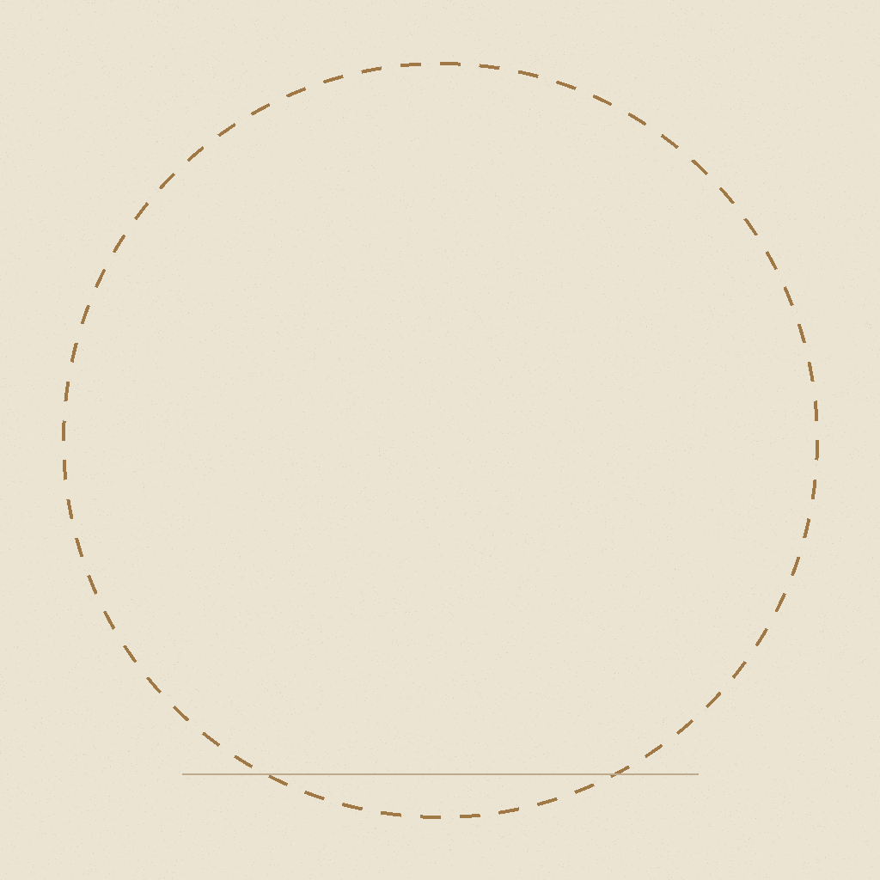
LEAFLET__frame.png — the silhouette fits inside the circle
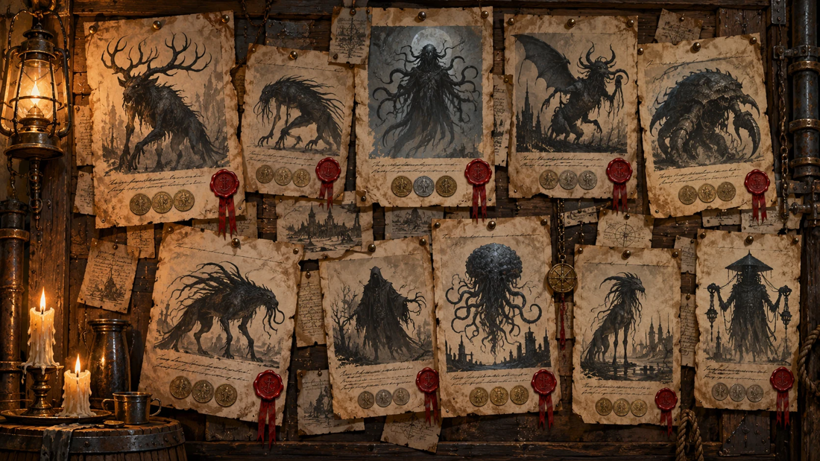
Style reference — silhouettes on the tavern leaflets (art/ui/TAVERN__contract_board.webp)
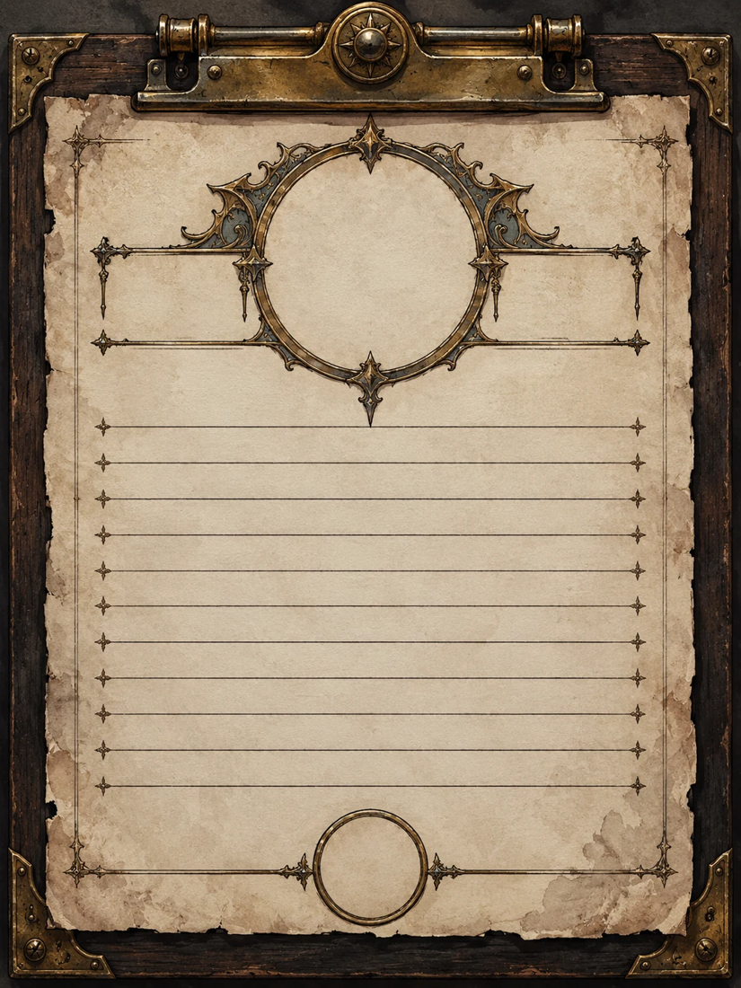
The contract tablet — the silhouette goes into the round frame at the top
COMBAT__frame.png (2:3, transparent with a dashed safe area and a ground ellipse) is in docs/assets/templates/monsters/.

B.4 Prompts, four per creature
Files go to assets/monsters/, e.g. GUTTER_CHOIR__combat__normal.png.

Gutter Choir [GUTTER_CHOIR · rank A]
Field | Value
Body parts | Left Throat, Right Throat
Phase 2 | The song rises (at 50% HP)
Rumor tags | children singing, wet handprints, near water, during rain, drowned shallow
1 — Combat art, first phase
[STYLE BLOCK]
Attached: COMBAT__frame.png (framing guide), TAVERN__contract_board (silhouette style reference).
Full-body art of the creature "Gutter Choir" (danger rank A) for the combat screen.
The creature: a cluster of pale, child-sized drowned figures fused at the shoulders into one dripping mass that rises out of a storm drain; two long throats stretch up like organ pipes, wet handprints all over its skin.
Mostly in deep shadow, lit by a cold rim light from behind and a weak warm light from the front;
slightly turned (3/4 view), standing on the ground line of the frame, filling the dashed safe area.
These body parts must be clearly visible and separate from each other (the player aims at them):
Left Throat, Right Throat.
Wrong proportions rather than gore. Transparent background, no floor, no text.
Output: transparent PNG, 2:3 portrait (1024×1536).
2 — Combat art, second phase
[STYLE BLOCK]
Attached: GUTTER_CHOIR__combat__normal.png (the same creature, first phase).
Repaint THE SAME CREATURE in the same pose, camera, scale and position — its second phase
"The song rises":
the mass splits open into a ring of singing mouths, water pouring from every throat, the children's faces stretched into one long scream.
Keep the body parts Left Throat, Right Throat in the same places; broken-looking is fine.
Stronger glow, more threatening. Transparent background, no text.
Output: transparent PNG, 2:3 portrait (1024×1536).
3 — Leaflet silhouette
[STYLE BLOCK]
Attached: GUTTER_CHOIR__combat__normal.png (the creature), LEAFLET__frame.png (size guide),
TAVERN__contract_board (how silhouettes look on hunters' leaflets).
A pure flat black silhouette (#120D0B) of the attached creature, as drawn on a hunters' contract
leaflet by a witness: same pose, slightly exaggerated, readable even at 96 px.
No inner details, no eyes, no shading, no outline of another colour.
It must fit inside the dashed circle of the frame with a little margin, standing on the line.
Transparent background (do not paint the parchment). No text.
Output: transparent PNG, 1:1 (1024×1024).
4 — Cracked silhouette
[STYLE BLOCK]
Attached: GUTTER_CHOIR__silhouette__leaflet.png, GUTTER_CHOIR__combat__phase2.png.
The SAME black silhouette, cracked like broken porcelain: through thin glowing cracks a glimpse of
the creature's true form shows (the mass splits open into a ring of singing mouths, water pouring from every throat, the children's faces stretched into one long scream).
Keep the outline identical. Transparent background, no text.
Output: transparent PNG, 1:1 (1024×1024).

Moth Matron [MOTH_MATRON · rank A]
Field | Value
Body parts | Wings
Phase 2 | The swarm wakes (at 40% HP)
Rumor tags | dust on sleepers, moonlight, never wake, silent wings
1 — Combat art, first phase
[STYLE BLOCK]
Attached: COMBAT__frame.png (framing guide), TAVERN__contract_board (silhouette style reference).
Full-body art of the creature "Moth Matron" (danger rank A) for the combat screen.
The creature: a tall moth-woman in a ragged nightgown made of grey wings, huge dusty compound eyes, thin arms cradling silk cocoons with sleeping people inside.
Mostly in deep shadow, lit by a cold rim light from behind and a weak warm light from the front;
slightly turned (3/4 view), standing on the ground line of the frame, filling the dashed safe area.
These body parts must be clearly visible and separate from each other (the player aims at them):
Wings.
Wrong proportions rather than gore. Transparent background, no floor, no text.
Output: transparent PNG, 2:3 portrait (1024×1536).
2 — Combat art, second phase
[STYLE BLOCK]
Attached: MOTH_MATRON__combat__normal.png (the same creature, first phase).
Repaint THE SAME CREATURE in the same pose, camera, scale and position — its second phase
"The swarm wakes":
the nightgown opens into enormous wings covered in eye-patterns, a cloud of smaller moths pouring out of her body.
Keep the body parts Wings in the same places; broken-looking is fine.
Stronger glow, more threatening. Transparent background, no text.
Output: transparent PNG, 2:3 portrait (1024×1536).
3 — Leaflet silhouette
[STYLE BLOCK]
Attached: MOTH_MATRON__combat__normal.png (the creature), LEAFLET__frame.png (size guide),
TAVERN__contract_board (how silhouettes look on hunters' leaflets).
A pure flat black silhouette (#120D0B) of the attached creature, as drawn on a hunters' contract
leaflet by a witness: same pose, slightly exaggerated, readable even at 96 px.
No inner details, no eyes, no shading, no outline of another colour.
It must fit inside the dashed circle of the frame with a little margin, standing on the line.
Transparent background (do not paint the parchment). No text.
Output: transparent PNG, 1:1 (1024×1024).
4 — Cracked silhouette
[STYLE BLOCK]
Attached: MOTH_MATRON__silhouette__leaflet.png, MOTH_MATRON__combat__phase2.png.
The SAME black silhouette, cracked like broken porcelain: through thin glowing cracks a glimpse of
the creature's true form shows (the nightgown opens into enormous wings covered in eye-patterns, a cloud of smaller moths pouring out of her body).
Keep the outline identical. Transparent background, no text.
Output: transparent PNG, 1:1 (1024×1024).

The Lamplighter [LAMPLIGHTER · rank P]
Field | Value
Body parts | Lantern, Long Hands
Phase 2 | The light goes out (at 50% HP)
Rumor tags | lamps die, too tall, only in fog, burnt eyes
1 — Combat art, first phase
[STYLE BLOCK]
Attached: COMBAT__frame.png (framing guide), TAVERN__contract_board (silhouette style reference).
Full-body art of the creature "The Lamplighter" (danger rank P) for the combat screen.
The creature: an impossibly tall, thin figure in a long coat and stovepipe hat, carrying a lamplighter's pole with a lantern of black flame, its hands too long with too many joints.
Mostly in deep shadow, lit by a cold rim light from behind and a weak warm light from the front;
slightly turned (3/4 view), standing on the ground line of the frame, filling the dashed safe area.
These body parts must be clearly visible and separate from each other (the player aims at them):
Lantern, Long Hands.
Wrong proportions rather than gore. Transparent background, no floor, no text.
Output: transparent PNG, 2:3 portrait (1024×1536).
2 — Combat art, second phase
[STYLE BLOCK]
Attached: LAMPLIGHTER__combat__normal.png (the same creature, first phase).
Repaint THE SAME CREATURE in the same pose, camera, scale and position — its second phase
"The light goes out":
the hat and face burn away to a hollow lantern-head full of black fire; the long hands unfold like spider legs.
Keep the body parts Lantern, Long Hands in the same places; broken-looking is fine.
Stronger glow, more threatening. Transparent background, no text.
Output: transparent PNG, 2:3 portrait (1024×1536).
3 — Leaflet silhouette
[STYLE BLOCK]
Attached: LAMPLIGHTER__combat__normal.png (the creature), LEAFLET__frame.png (size guide),
TAVERN__contract_board (how silhouettes look on hunters' leaflets).
A pure flat black silhouette (#120D0B) of the attached creature, as drawn on a hunters' contract
leaflet by a witness: same pose, slightly exaggerated, readable even at 96 px.
No inner details, no eyes, no shading, no outline of another colour.
It must fit inside the dashed circle of the frame with a little margin, standing on the line.
Transparent background (do not paint the parchment). No text.
Output: transparent PNG, 1:1 (1024×1024).
4 — Cracked silhouette
[STYLE BLOCK]
Attached: LAMPLIGHTER__silhouette__leaflet.png, LAMPLIGHTER__combat__phase2.png.
The SAME black silhouette, cracked like broken porcelain: through thin glowing cracks a glimpse of
the creature's true form shows (the hat and face burn away to a hollow lantern-head full of black fire).
Keep the outline identical. Transparent background, no text.
Output: transparent PNG, 1:1 (1024×1024).

Rust Mantis [RUST_MANTIS · rank P]
Field | Value
Body parts | Left Scythe, Right Scythe
Phase 2 | Rust frenzy (at 50% HP)
Rumor tags | grinding metal, acid burns, foundries, eats machinery
1 — Combat art, first phase
[STYLE BLOCK]
Attached: COMBAT__frame.png (framing guide), TAVERN__contract_board (silhouette style reference).
Full-body art of the creature "Rust Mantis" (danger rank P) for the combat screen.
The creature: a mantis made of corroded iron plates and wet sinew, two scythe arms built from old saw blades, acid dripping from its jaws, sparks where metal grinds.
Mostly in deep shadow, lit by a cold rim light from behind and a weak warm light from the front;
slightly turned (3/4 view), standing on the ground line of the frame, filling the dashed safe area.
These body parts must be clearly visible and separate from each other (the player aims at them):
Left Scythe, Right Scythe.
Wrong proportions rather than gore. Transparent background, no floor, no text.
Output: transparent PNG, 2:3 portrait (1024×1536).
2 — Combat art, second phase
[STYLE BLOCK]
Attached: RUST_MANTIS__combat__normal.png (the same creature, first phase).
Repaint THE SAME CREATURE in the same pose, camera, scale and position — its second phase
"Rust frenzy":
the plates flare open like a rusted crown, steam and acid spraying from the joints, the scythes glowing red-hot.
Keep the body parts Left Scythe, Right Scythe in the same places; broken-looking is fine.
Stronger glow, more threatening. Transparent background, no text.
Output: transparent PNG, 2:3 portrait (1024×1536).
3 — Leaflet silhouette
[STYLE BLOCK]
Attached: RUST_MANTIS__combat__normal.png (the creature), LEAFLET__frame.png (size guide),
TAVERN__contract_board (how silhouettes look on hunters' leaflets).
A pure flat black silhouette (#120D0B) of the attached creature, as drawn on a hunters' contract
leaflet by a witness: same pose, slightly exaggerated, readable even at 96 px.
No inner details, no eyes, no shading, no outline of another colour.
It must fit inside the dashed circle of the frame with a little margin, standing on the line.
Transparent background (do not paint the parchment). No text.
Output: transparent PNG, 1:1 (1024×1024).
4 — Cracked silhouette
[STYLE BLOCK]
Attached: RUST_MANTIS__silhouette__leaflet.png, RUST_MANTIS__combat__phase2.png.
The SAME black silhouette, cracked like broken porcelain: through thin glowing cracks a glimpse of
the creature's true form shows (the plates flare open like a rusted crown, steam and acid spraying from the joints, the scythes glowing red-hot).
Keep the outline identical. Transparent background, no text.
Output: transparent PNG, 1:1 (1024×1024).

Mourning Bride [MOURNING_BRIDE · rank P]
Field | Value
Body parts | Veil, Hand Mirror
Phase 2 | The mirror cracks (at 50% HP)
Rumor tags | covered mirrors, one guest too many, victim smiling, perfume
1 — Combat art, first phase
[STYLE BLOCK]
Attached: COMBAT__frame.png (framing guide), TAVERN__contract_board (silhouette style reference).
Full-body art of the creature "Mourning Bride" (danger rank P) for the combat screen.
The creature: a bride in a black veil and a tattered wedding dress, holding a silver hand mirror; her fingers are too many and too long; the reflection in the mirror is not her.
Mostly in deep shadow, lit by a cold rim light from behind and a weak warm light from the front;
slightly turned (3/4 view), standing on the ground line of the frame, filling the dashed safe area.
These body parts must be clearly visible and separate from each other (the player aims at them):
Veil, Hand Mirror.
Wrong proportions rather than gore. Transparent background, no floor, no text.
Output: transparent PNG, 2:3 portrait (1024×1536).
2 — Combat art, second phase
[STYLE BLOCK]
Attached: MOURNING_BRIDE__combat__normal.png (the same creature, first phase).
Repaint THE SAME CREATURE in the same pose, camera, scale and position — its second phase
"The mirror cracks":
the mirror cracks and her reflection climbs out of it; two brides joined at the back, veils torn, glass shards circling them.
Keep the body parts Veil, Hand Mirror in the same places; broken-looking is fine.
Stronger glow, more threatening. Transparent background, no text.
Output: transparent PNG, 2:3 portrait (1024×1536).
3 — Leaflet silhouette
[STYLE BLOCK]
Attached: MOURNING_BRIDE__combat__normal.png (the creature), LEAFLET__frame.png (size guide),
TAVERN__contract_board (how silhouettes look on hunters' leaflets).
A pure flat black silhouette (#120D0B) of the attached creature, as drawn on a hunters' contract
leaflet by a witness: same pose, slightly exaggerated, readable even at 96 px.
No inner details, no eyes, no shading, no outline of another colour.
It must fit inside the dashed circle of the frame with a little margin, standing on the line.
Transparent background (do not paint the parchment). No text.
Output: transparent PNG, 1:1 (1024×1024).
4 — Cracked silhouette
[STYLE BLOCK]
Attached: MOURNING_BRIDE__silhouette__leaflet.png, MOURNING_BRIDE__combat__phase2.png.
The SAME black silhouette, cracked like broken porcelain: through thin glowing cracks a glimpse of
the creature's true form shows (the mirror cracks and her reflection climbs out of it).
Keep the outline identical. Transparent background, no text.
Output: transparent PNG, 1:1 (1024×1024).

Vigil Hound [VIGIL_HOUND · rank P]
Field | Value
Body parts | Jaw, Hind Legs
Phase 2 | The hunter is gone (at 50% HP)
Rumor tags | howl, prints turn to paws, smell of medicine, former hunter
1 — Combat art, first phase
[STYLE BLOCK]
Attached: COMBAT__frame.png (framing guide), TAVERN__contract_board (silhouette style reference).
Full-body art of the creature "Vigil Hound" (danger rank P) for the combat screen.
The creature: a former monster hunter caught halfway into a huge wolf-like beast: torn hunter's coat and belts still on its body, empty syringes stuck in the fur, one human hand left.
Mostly in deep shadow, lit by a cold rim light from behind and a weak warm light from the front;
slightly turned (3/4 view), standing on the ground line of the frame, filling the dashed safe area.
These body parts must be clearly visible and separate from each other (the player aims at them):
Jaw, Hind Legs.
Wrong proportions rather than gore. Transparent background, no floor, no text.
Output: transparent PNG, 2:3 portrait (1024×1536).
2 — Combat art, second phase
[STYLE BLOCK]
Attached: VIGIL_HOUND__combat__normal.png (the same creature, first phase).
Repaint THE SAME CREATURE in the same pose, camera, scale and position — its second phase
"The hunter is gone":
the last human parts are gone: a massive hound with a split jaw, the hunter's hat snagged on one ear, eyes burning like lamps.
Keep the body parts Jaw, Hind Legs in the same places; broken-looking is fine.
Stronger glow, more threatening. Transparent background, no text.
Output: transparent PNG, 2:3 portrait (1024×1536).
3 — Leaflet silhouette
[STYLE BLOCK]
Attached: VIGIL_HOUND__combat__normal.png (the creature), LEAFLET__frame.png (size guide),
TAVERN__contract_board (how silhouettes look on hunters' leaflets).
A pure flat black silhouette (#120D0B) of the attached creature, as drawn on a hunters' contract
leaflet by a witness: same pose, slightly exaggerated, readable even at 96 px.
No inner details, no eyes, no shading, no outline of another colour.
It must fit inside the dashed circle of the frame with a little margin, standing on the line.
Transparent background (do not paint the parchment). No text.
Output: transparent PNG, 1:1 (1024×1024).
4 — Cracked silhouette
[STYLE BLOCK]
Attached: VIGIL_HOUND__silhouette__leaflet.png, VIGIL_HOUND__combat__phase2.png.
The SAME black silhouette, cracked like broken porcelain: through thin glowing cracks a glimpse of
the creature's true form shows (the last human parts are gone: a massive hound with a split jaw, the hunter's hat snagged on one ear, eyes burning like lamps).
Keep the outline identical. Transparent background, no text.
Output: transparent PNG, 1:1 (1024×1024).

Clay Saint [CLAY_SAINT · rank P]
Field | Value
Body parts | Head, Core
Phase 2 | The procedure begins (at 50% HP)
Rumor tags | formalin, glass chiming, surgical wounds, walks in daylight
1 — Combat art, first phase
[STYLE BLOCK]
Attached: COMBAT__frame.png (framing guide), TAVERN__contract_board (silhouette style reference).
Full-body art of the creature "Clay Saint" (danger rank P) for the combat screen.
The creature: an artificial human of cracked white clay and brass joints, a halo-like ring of floating scalpels behind its head, a glowing core visible through a hole in its chest.
Mostly in deep shadow, lit by a cold rim light from behind and a weak warm light from the front;
slightly turned (3/4 view), standing on the ground line of the frame, filling the dashed safe area.
These body parts must be clearly visible and separate from each other (the player aims at them):
Head, Core.
Wrong proportions rather than gore. Transparent background, no floor, no text.
Output: transparent PNG, 2:3 portrait (1024×1536).
2 — Combat art, second phase
[STYLE BLOCK]
Attached: CLAY_SAINT__combat__normal.png (the same creature, first phase).
Repaint THE SAME CREATURE in the same pose, camera, scale and position — its second phase
"The procedure begins":
the clay shell peels away showing brass ribs and the bright core; the scalpels spin faster, extra surgical arms unfold from its back.
Keep the body parts Head, Core in the same places; broken-looking is fine.
Stronger glow, more threatening. Transparent background, no text.
Output: transparent PNG, 2:3 portrait (1024×1536).
3 — Leaflet silhouette
[STYLE BLOCK]
Attached: CLAY_SAINT__combat__normal.png (the creature), LEAFLET__frame.png (size guide),
TAVERN__contract_board (how silhouettes look on hunters' leaflets).
A pure flat black silhouette (#120D0B) of the attached creature, as drawn on a hunters' contract
leaflet by a witness: same pose, slightly exaggerated, readable even at 96 px.
No inner details, no eyes, no shading, no outline of another colour.
It must fit inside the dashed circle of the frame with a little margin, standing on the line.
Transparent background (do not paint the parchment). No text.
Output: transparent PNG, 1:1 (1024×1024).
4 — Cracked silhouette
[STYLE BLOCK]
Attached: CLAY_SAINT__silhouette__leaflet.png, CLAY_SAINT__combat__phase2.png.
The SAME black silhouette, cracked like broken porcelain: through thin glowing cracks a glimpse of
the creature's true form shows (the clay shell peels away showing brass ribs and the bright core).
Keep the outline identical. Transparent background, no text.
Output: transparent PNG, 1:1 (1024×1024).

Burrow Wyrm [BURROW_WYRM · rank D]
Field | Value
Body parts | Maw, Shell, Tail
Phase 2 | The floor gives way (at 50% HP)
Rumor tags | tremors, floors collapse, acid, knocking below
1 — Combat art, first phase
[STYLE BLOCK]
Attached: COMBAT__frame.png (framing guide), TAVERN__contract_board (silhouette style reference).
Full-body art of the creature "Burrow Wyrm" (danger rank D) for the combat screen.
The creature: a giant segmented worm-beast with layered chitin plates, a round maw lined with rings of teeth, a spiked armoured tail, bursting out of a broken mine floor.
Mostly in deep shadow, lit by a cold rim light from behind and a weak warm light from the front;
slightly turned (3/4 view), standing on the ground line of the frame, filling the dashed safe area.
These body parts must be clearly visible and separate from each other (the player aims at them):
Maw, Shell, Tail.
Wrong proportions rather than gore. Transparent background, no floor, no text.
Output: transparent PNG, 2:3 portrait (1024×1536).
2 — Combat art, second phase
[STYLE BLOCK]
Attached: BURROW_WYRM__combat__normal.png (the same creature, first phase).
Repaint THE SAME CREATURE in the same pose, camera, scale and position — its second phase
"The floor gives way":
the shell splits along its back, acid steaming from the cracks; the maw opens wider than its body, the tunnel collapsing around it.
Keep the body parts Maw, Shell, Tail in the same places; broken-looking is fine.
Stronger glow, more threatening. Transparent background, no text.
Output: transparent PNG, 2:3 portrait (1024×1536).
3 — Leaflet silhouette
[STYLE BLOCK]
Attached: BURROW_WYRM__combat__normal.png (the creature), LEAFLET__frame.png (size guide),
TAVERN__contract_board (how silhouettes look on hunters' leaflets).
A pure flat black silhouette (#120D0B) of the attached creature, as drawn on a hunters' contract
leaflet by a witness: same pose, slightly exaggerated, readable even at 96 px.
No inner details, no eyes, no shading, no outline of another colour.
It must fit inside the dashed circle of the frame with a little margin, standing on the line.
Transparent background (do not paint the parchment). No text.
Output: transparent PNG, 1:1 (1024×1024).
4 — Cracked silhouette
[STYLE BLOCK]
Attached: BURROW_WYRM__silhouette__leaflet.png, BURROW_WYRM__combat__phase2.png.
The SAME black silhouette, cracked like broken porcelain: through thin glowing cracks a glimpse of
the creature's true form shows (the shell splits along its back, acid steaming from the cracks).
Keep the outline identical. Transparent background, no text.
Output: transparent PNG, 1:1 (1024×1024).

D. Game Icons
Every icon the game needs: 152 icons in 22 sets. The catalog is data/ui/icons.json — the game, the import tool and this document all read it, so ids and order never drift apart.

D.1 Four icon styles
Style | Used for | Size in game
Object | Resources, weapon sections, armor, day actions — things you can hold | 64–256 px
Symbol | Stats, statuses, intents, card types, tags, outcomes, UI buttons — must read at 32 px | 24–96 px
Crest | Factions and districts | 48–256 px
Badge | Register ranks A / P / D / S (the letter is added by the game) | 32–96 px
ICON STYLE — OBJECT:
A painted game icon of an object, slight 3/4 view, thick dark ink outline,
painted metal / leather / wood / glass with wear, warm light from the top-left —
exactly the look of the attached resource icons. Readable at 64 px.
ICON STYLE — SYMBOL:
A small game symbol icon that must read at 32 px: one simple bold shape,
cast in dark tarnished brass like a token or engraved badge, thick dark outline,
minimal inner detail, strong silhouette. Palette: brass, soot black, parchment,
plus ONE accent colour only where it carries meaning (blood red, cold blue, sickly green, violet).
ICON STYLE — CREST:
A heraldic emblem: a bold central symbol pressed into an aged round wax seal or painted on a
small chipped iron shield. Readable at 64 px, no lettering, no banners with words.
ICON STYLE — BADGE:
A blank metal rank badge with an EMPTY, smooth centre (the game prints a letter there).
Front view, thick dark outline, aged metal. No letters, no numbers.

D.2 How icon sheets work
- Icons are generated as sheets of up to 6, in one row, in the order listed — exactly like the existing resource sheet.
- Save a sheet as assets/icons/<SET>__sheet__<n>.png. python tools/import_art.py cuts it into art/ui/icons/<SET>__<id>.webp using the order from the catalog.
- If one icon of a sheet is bad, regenerate the whole sheet (attach the previous version and ask to change only that icon), so the order stays right.
- Icons may touch slightly — the cutter separates them by their solid cores — but clear gaps are safest.
Style reference for all icons — the resource sheet (already done)

D.3 Icon catalog and prompts

RESOURCE — 6 icons · Object icon · DONE
Resources (GDD 6.1). Already generated — keep for re-generation.
File | Name | Where it is used | Look
RESOURCE__gears | Gears | Resource counter, shop, crafting costs | a single worn brass cogwheel with rivets
RESOURCE__scrap | Work scrap | Resource counter, shop, crafting costs | a small pile of rusty pipes, nuts and bent plates
RESOURCE__electronics | Electronics | Resource counter, shop, crafting costs | a small brass-framed circuit board with two glass capacitors
RESOURCE__ichor | Ichor | Resource counter, Monster web, blood modules | a glossy drop of dark red blood with small drips
RESOURCE__trophy | Trophies | Loot from broken body parts | a long bloody fang or claw with a torn root
RESOURCE__money | Money | Money counter, rewards, prices | a gold coin with a laurelled profile
[STYLE BLOCK]
[ICON STYLE — OBJECT]
Attached: RESOURCE icons (style reference).
A sheet of 6 game icons for: Resources (GDD 6.1). Already generated — keep for re-generation.
Draw them in ONE horizontal row, left to right in this exact order, all the same size,
each centred in its own equal slot, with clear empty space between them (they must not touch):
1. Gears — a single worn brass cogwheel with rivets
2. Work scrap — a small pile of rusty pipes, nuts and bent plates
3. Electronics — a small brass-framed circuit board with two glass capacitors
4. Ichor — a glossy drop of dark red blood with small drips
5. Trophies — a long bloody fang or claw with a torn root
6. Money — a gold coin with a laurelled profile
Transparent background. No text, no labels, no numbers, no frames or circles around the icons.
Output: transparent PNG, 3:2 landscape (1536×1024). Save as RESOURCE__sheet__1.png (sheet 1 of 1).

STAT — 8 icons · Symbol icon
The hunter's counters on the left edge of the combat screen and in menus (GDD 4.2).
File | Name | Where it is used | Look
STAT__hp | Health | HP counter | an anatomical heart wrapped in a brass band
STAT__sanity | Sanity | Sanity counter, Fear damage | an open eye inside a cracked glass circle
STAT__ap | Action points | AP counter, card cost | a brass hourglass-shaped token with three notches
STAT__block | Block | Block value on hunter and creature | a round riveted iron buckler
STAT__ammo | Ammo | Weapon card, ammo cost on cards | a single brass rifle cartridge standing upright
STAT__voice | The Voice | Corruption meter, Monster web | a bloody mouth with fangs inside a ring of sound waves
STAT__xp | Experience | Level bar | a hunter's mark: crossed knife and quill over a small skull
STAT__skill_point | Skill point | Skill web, level up | a glowing brass rivet shaped like a star node of a web
[STYLE BLOCK]
[ICON STYLE — SYMBOL]
Attached: RESOURCE icons (style reference).
A sheet of 6 game icons for: The hunter's counters on the left edge of the combat screen and in menus (GDD 4.2).
Draw them in ONE horizontal row, left to right in this exact order, all the same size,
each centred in its own equal slot, with clear empty space between them (they must not touch):
1. Health — an anatomical heart wrapped in a brass band
2. Sanity — an open eye inside a cracked glass circle
3. Action points — a brass hourglass-shaped token with three notches
4. Block — a round riveted iron buckler
5. Ammo — a single brass rifle cartridge standing upright
6. The Voice — a bloody mouth with fangs inside a ring of sound waves
Accents: health = blood red, sanity = violet, voice = dark red, all others brass only.
Transparent background. No text, no labels, no numbers, no frames or circles around the icons.
Output: transparent PNG, 3:2 landscape (1536×1024). Save as STAT__sheet__1.png (sheet 1 of 2).
[STYLE BLOCK]
[ICON STYLE — SYMBOL]
Attached: RESOURCE icons (style reference), STAT__sheet__1.png (keep exactly the same style and size).
A sheet of 2 game icons for: The hunter's counters on the left edge of the combat screen and in menus (GDD 4.2).
Draw them in ONE horizontal row, left to right in this exact order, all the same size,
each centred in its own equal slot, with clear empty space between them (they must not touch):
1. Experience — a hunter's mark: crossed knife and quill over a small skull
2. Skill point — a glowing brass rivet shaped like a star node of a web
Accents: health = blood red, sanity = violet, voice = dark red, all others brass only.
Transparent background. No text, no labels, no numbers, no frames or circles around the icons.
Output: transparent PNG, 3:2 landscape (1536×1024). Save as STAT__sheet__2.png (sheet 2 of 2).

ATTRIBUTE — 3 icons · Symbol icon
Will, Agility, Cunning (GDD 4.1).
File | Name | Where it is used | Look
ATTRIBUTE__will | Will | Character sheet, checks | a clenched gauntlet fist holding a candle flame
ATTRIBUTE__agility | Agility | Character sheet, checks | a feathered boot heel with motion lines of ink
ATTRIBUTE__cunning | Cunning | Character sheet, checks | a fox mask with one narrowed eye
[STYLE BLOCK]
[ICON STYLE — SYMBOL]
Attached: RESOURCE icons (style reference).
A sheet of 3 game icons for: Will, Agility, Cunning (GDD 4.1).
Draw them in ONE horizontal row, left to right in this exact order, all the same size,
each centred in its own equal slot, with clear empty space between them (they must not touch):
1. Will — a clenched gauntlet fist holding a candle flame
2. Agility — a feathered boot heel with motion lines of ink
3. Cunning — a fox mask with one narrowed eye
Transparent background. No text, no labels, no numbers, no frames or circles around the icons.
Output: transparent PNG, 3:2 landscape (1536×1024). Save as ATTRIBUTE__sheet__1.png (sheet 1 of 1).

STATUS — 6 icons · Symbol icon
Statuses on the hunter and the creature (GDD 9, combat rules).
File | Name | Where it is used | Look
STATUS__weak | Weak | Status: deals less damage | a broken sword blade drooping down
STATUS__exposed | Exposed | Status: takes more damage | a cracked breastplate with a gap
STATUS__bleed | Bleed | Status: loses HP each turn | three falling blood drops
STATUS__dodge | Dodge | Status: avoids the next attack | a swirl of grey smoke with a silhouette slipping away
STATUS__enraged | Enraged | Status: deals more damage | a red burning eye with a vertical pupil
STATUS__panic | Panic | Hunter at 0 Sanity | a trembling hand with spilled ink around it
[STYLE BLOCK]
[ICON STYLE — SYMBOL]
Attached: RESOURCE icons (style reference).
A sheet of 6 game icons for: Statuses on the hunter and the creature (GDD 9, combat rules).
Draw them in ONE horizontal row, left to right in this exact order, all the same size,
each centred in its own equal slot, with clear empty space between them (they must not touch):
1. Weak — a broken sword blade drooping down
2. Exposed — a cracked breastplate with a gap
3. Bleed — three falling blood drops
4. Dodge — a swirl of grey smoke with a silhouette slipping away
5. Enraged — a red burning eye with a vertical pupil
6. Panic — a trembling hand with spilled ink around it
Accents: weak = ochre, exposed = steel blue, bleed = blood red, dodge = fog grey, enraged = red-orange, panic = violet.
Transparent background. No text, no labels, no numbers, no frames or circles around the icons.
Output: transparent PNG, 3:2 landscape (1536×1024). Save as STATUS__sheet__1.png (sheet 1 of 1).

INTENT — 7 icons · Symbol icon
Icons on the creature's intent cards (GDD 9.4).
File | Name | Where it is used | Look
INTENT__attack | Attack | Intent: the creature will strike | three claw slashes
INTENT__defend | Defend | Intent: the creature will block | a chitin carapace shell
INTENT__fear | Fear | Intent: Sanity damage | a tentacled shadow over a small eye
INTENT__debuff | Debuff | Intent: weakens the hunter | a wilted thorn branch dripping black
INTENT__buff | Buff | Intent: strengthens itself | a rising red flame with fangs
INTENT__heal | Heal | Intent: heals itself | stitched flesh with a sewing needle
INTENT__unknown | Unknown | Intent hidden or cancelled | a black question-shaped smoke curl
[STYLE BLOCK]
[ICON STYLE — SYMBOL]
Attached: RESOURCE icons (style reference).
A sheet of 6 game icons for: Icons on the creature's intent cards (GDD 9.4).
Draw them in ONE horizontal row, left to right in this exact order, all the same size,
each centred in its own equal slot, with clear empty space between them (they must not touch):
1. Attack — three claw slashes
2. Defend — a chitin carapace shell
3. Fear — a tentacled shadow over a small eye
4. Debuff — a wilted thorn branch dripping black
5. Buff — a rising red flame with fangs
6. Heal — stitched flesh with a sewing needle
Accents (match the intent card borders): attack = red #B03A2E, defend = steel #6E7A8A, fear = violet #6B4A8A, debuff = ochre #8A7A3A, buff = orange #A05A2A, heal = green #4F7A4A, unknown = grey.
Transparent background. No text, no labels, no numbers, no frames or circles around the icons.
Output: transparent PNG, 3:2 landscape (1536×1024). Save as INTENT__sheet__1.png (sheet 1 of 2).
[STYLE BLOCK]
[ICON STYLE — SYMBOL]
Attached: RESOURCE icons (style reference), INTENT__sheet__1.png (keep exactly the same style and size).
A sheet of 1 game icons for: Icons on the creature's intent cards (GDD 9.4).
Draw them in ONE horizontal row, left to right in this exact order, all the same size,
each centred in its own equal slot, with clear empty space between them (they must not touch):
1. Unknown — a black question-shaped smoke curl
Accents (match the intent card borders): attack = red #B03A2E, defend = steel #6E7A8A, fear = violet #6B4A8A, debuff = ochre #8A7A3A, buff = orange #A05A2A, heal = green #4F7A4A, unknown = grey.
Transparent background. No text, no labels, no numbers, no frames or circles around the icons.
Output: transparent PNG, 3:2 landscape (1536×1024). Save as INTENT__sheet__2.png (sheet 2 of 2).

CARD_TYPE — 6 icons · Symbol icon
Small badge in the corner of every card (GDD 9.3).
File | Name | Where it is used | Look
CARD_TYPE__attack | Attack | Card type badge | a hunting knife crossed with a rifle
CARD_TYPE__support | Support | Card type badge | a brass gear with a small shield
CARD_TYPE__consumable | Consumable | Card type badge | a corked glass vial
CARD_TYPE__capture | Capture | Card type badge | a folded iron net with lead weights
CARD_TYPE__rage | Rage | Card type badge | a bloody fist
CARD_TYPE__curse | Curse | Card type badge | a black thorned seal
[STYLE BLOCK]
[ICON STYLE — SYMBOL]
Attached: RESOURCE icons (style reference).
A sheet of 6 game icons for: Small badge in the corner of every card (GDD 9.3).
Draw them in ONE horizontal row, left to right in this exact order, all the same size,
each centred in its own equal slot, with clear empty space between them (they must not touch):
1. Attack — a hunting knife crossed with a rifle
2. Support — a brass gear with a small shield
3. Consumable — a corked glass vial
4. Capture — a folded iron net with lead weights
5. Rage — a bloody fist
6. Curse — a black thorned seal
Transparent background. No text, no labels, no numbers, no frames or circles around the icons.
Output: transparent PNG, 3:2 landscape (1536×1024). Save as CARD_TYPE__sheet__1.png (sheet 1 of 1).

CELL — 3 icons · Symbol icon
Cell types of the weapon grid and armor sockets (GDD 5.2).
File | Name | Where it is used | Look
CELL__gear | Gear cell | Weapon grid, module cards | a brass square socket with a cog engraved
CELL__spark | Spark cell | Weapon grid, module cards | a copper square socket with a blue lightning sign
CELL__blood | Blood cell | Weapon grid, module cards | a bone square socket with a red drop inside
[STYLE BLOCK]
[ICON STYLE — SYMBOL]
Attached: RESOURCE icons (style reference).
A sheet of 3 game icons for: Cell types of the weapon grid and armor sockets (GDD 5.2).
Draw them in ONE horizontal row, left to right in this exact order, all the same size,
each centred in its own equal slot, with clear empty space between them (they must not touch):
1. Gear cell — a brass square socket with a cog engraved
2. Spark cell — a copper square socket with a blue lightning sign
3. Blood cell — a bone square socket with a red drop inside
Accents: gear = warm brass, spark = cold blue glow, blood = dark red.
Transparent background. No text, no labels, no numbers, no frames or circles around the icons.
Output: transparent PNG, 3:2 landscape (1536×1024). Save as CELL__sheet__1.png (sheet 1 of 1).

SECTION — 5 icons · Object icon
The five sections of a weapon (GDD 5.2).
File | Name | Where it is used | Look
SECTION__sight | Sight | Weapon tablet labels, module filters | a brass rifle scope
SECTION__magazine | Magazine | Weapon tablet labels, module filters | a box magazine with cartridges
SECTION__stock | Stock | Weapon tablet labels, module filters | a wooden rifle stock with a brass butt plate
SECTION__frame | Frame | Weapon tablet labels, module filters | a riveted steel rifle receiver
SECTION__barrel | Barrel | Weapon tablet labels, module filters | a short rifle barrel with a muzzle brake
[STYLE BLOCK]
[ICON STYLE — OBJECT]
Attached: RESOURCE icons (style reference).
A sheet of 5 game icons for: The five sections of a weapon (GDD 5.2).
Draw them in ONE horizontal row, left to right in this exact order, all the same size,
each centred in its own equal slot, with clear empty space between them (they must not touch):
1. Sight — a brass rifle scope
2. Magazine — a box magazine with cartridges
3. Stock — a wooden rifle stock with a brass butt plate
4. Frame — a riveted steel rifle receiver
5. Barrel — a short rifle barrel with a muzzle brake
Transparent background. No text, no labels, no numbers, no frames or circles around the icons.
Output: transparent PNG, 3:2 landscape (1536×1024). Save as SECTION__sheet__1.png (sheet 1 of 1).

ARMOR — 5 icons · Object icon
Armor pieces and the mechanism socket (GDD 5.1).
File | Name | Where it is used | Look
ARMOR__helmet | Helmet | Equipment screen, Equipment web | a hunter's wide-brimmed hat with a steel plague-mask visor
ARMOR__chestplate | Chestplate | Equipment screen, Equipment web | a leather coat with a riveted steel chestplate
ARMOR__gauntlets | Gauntlets & Pauldrons | Equipment screen, Equipment web | a steel gauntlet with a shoulder pauldron
ARMOR__greaves | Greaves | Equipment screen, Equipment web | tall buckled boots with steel shin plates
ARMOR__mechanism_socket | Mechanism socket | Empty socket on armor | a round empty brass socket with screw holes
[STYLE BLOCK]
[ICON STYLE — OBJECT]
Attached: RESOURCE icons (style reference).
A sheet of 5 game icons for: Armor pieces and the mechanism socket (GDD 5.1).
Draw them in ONE horizontal row, left to right in this exact order, all the same size,
each centred in its own equal slot, with clear empty space between them (they must not touch):
1. Helmet — a hunter's wide-brimmed hat with a steel plague-mask visor
2. Chestplate — a leather coat with a riveted steel chestplate
3. Gauntlets & Pauldrons — a steel gauntlet with a shoulder pauldron
4. Greaves — tall buckled boots with steel shin plates
5. Mechanism socket — a round empty brass socket with screw holes
Transparent background. No text, no labels, no numbers, no frames or circles around the icons.
Output: transparent PNG, 3:2 landscape (1536×1024). Save as ARMOR__sheet__1.png (sheet 1 of 1).

SKILL — 6 icons · Symbol icon
Skill webs and node types (GDD 4.4).
File | Name | Where it is used | Look
SKILL__mechanic | The Mechanic | Web emblem | a cogwheel inside a spider web made of wire
SKILL__monster | The Monster | Web emblem | a fanged maw inside a spider web made of veins
SKILL__passive | Passive node | Skill node | a small round brass rivet
SKILL__blueprint | Blueprint node | Skill node | a rolled blueprint with a wax seal
SKILL__socket | Socket node | Skill node | an empty round socket
SKILL__keystone | Keystone node | Skill node | an ornate brass key head with a red gem
[STYLE BLOCK]
[ICON STYLE — SYMBOL]
Attached: RESOURCE icons (style reference).
A sheet of 6 game icons for: Skill webs and node types (GDD 4.4).
Draw them in ONE horizontal row, left to right in this exact order, all the same size,
each centred in its own equal slot, with clear empty space between them (they must not touch):
1. The Mechanic — a cogwheel inside a spider web made of wire
2. The Monster — a fanged maw inside a spider web made of veins
3. Passive node — a small round brass rivet
4. Blueprint node — a rolled blueprint with a wax seal
5. Socket node — an empty round socket
6. Keystone node — an ornate brass key head with a red gem
Transparent background. No text, no labels, no numbers, no frames or circles around the icons.
Output: transparent PNG, 3:2 landscape (1536×1024). Save as SKILL__sheet__1.png (sheet 1 of 1).

DIRECTION — 4 icons · Symbol icon
The four directions of each skill web (GDD 4.4).
File | Name | Where it is used | Look
DIRECTION__equipment | Equipment | Web direction | a helmet with a pauldron
DIRECTION__weapon | Weapon | Web direction | a rifle seen from the side
DIRECTION__modules | Weapon modules | Web direction | an L-shaped piece made of square cells
DIRECTION__mechanisms | Mechanisms | Web direction | a small clockwork device with a spring
[STYLE BLOCK]
[ICON STYLE — SYMBOL]
Attached: RESOURCE icons (style reference).
A sheet of 4 game icons for: The four directions of each skill web (GDD 4.4).
Draw them in ONE horizontal row, left to right in this exact order, all the same size,
each centred in its own equal slot, with clear empty space between them (they must not touch):
1. Equipment — a helmet with a pauldron
2. Weapon — a rifle seen from the side
3. Weapon modules — an L-shaped piece made of square cells
4. Mechanisms — a small clockwork device with a spring
Transparent background. No text, no labels, no numbers, no frames or circles around the icons.
Output: transparent PNG, 3:2 landscape (1536×1024). Save as DIRECTION__sheet__1.png (sheet 1 of 1).

CONTRACT — 6 icons · Symbol icon
Contract types and the tracker (GDD 7).
File | Name | Where it is used | Look
CONTRACT__slay | Slay | Contract type | a skull pierced by a harpoon
CONTRACT__capture | Capture | Contract type | a beast silhouette under an iron net
CONTRACT__research | Research | Contract type | a magnifying glass over an anatomical sketch
CONTRACT__story | Story | Contract type | an open book with a ribbon bookmark
CONTRACT__deadline | Deadline | Days left on contracts | a small brass hourglass with red sand
CONTRACT__region | Region | Tracker: show where it was seen | a brass map pin over a fragment of a city map
[STYLE BLOCK]
[ICON STYLE — SYMBOL]
Attached: RESOURCE icons (style reference).
A sheet of 6 game icons for: Contract types and the tracker (GDD 7).
Draw them in ONE horizontal row, left to right in this exact order, all the same size,
each centred in its own equal slot, with clear empty space between them (they must not touch):
1. Slay — a skull pierced by a harpoon
2. Capture — a beast silhouette under an iron net
3. Research — a magnifying glass over an anatomical sketch
4. Story — an open book with a ribbon bookmark
5. Deadline — a small brass hourglass with red sand
6. Region — a brass map pin over a fragment of a city map
Transparent background. No text, no labels, no numbers, no frames or circles around the icons.
Output: transparent PNG, 3:2 landscape (1536×1024). Save as CONTRACT__sheet__1.png (sheet 1 of 1).

OUTCOME — 5 icons · Symbol icon
What an investigated rumor turned out to be (GDD 8.3).
File | Name | Where it is used | Look
OUTCOME__target | The target | Rumor result | a crosshair over a black silhouette
OUTCOME__wrong_monster | Wrong creature | Rumor result | two different silhouettes, one crossed out
OUTCOME__discovery | Discovery | Rumor result | an open chest with a faint glow
OUTCOME__false_lead | False lead | Rumor result | a torn leaflet
OUTCOME__empty_night | Empty night | Rumor result | a crescent moon over an empty alley
[STYLE BLOCK]
[ICON STYLE — SYMBOL]
Attached: RESOURCE icons (style reference).
A sheet of 5 game icons for: What an investigated rumor turned out to be (GDD 8.3).
Draw them in ONE horizontal row, left to right in this exact order, all the same size,
each centred in its own equal slot, with clear empty space between them (they must not touch):
1. The target — a crosshair over a black silhouette
2. Wrong creature — two different silhouettes, one crossed out
3. Discovery — an open chest with a faint glow
4. False lead — a torn leaflet
5. Empty night — a crescent moon over an empty alley
Transparent background. No text, no labels, no numbers, no frames or circles around the icons.
Output: transparent PNG, 3:2 landscape (1536×1024). Save as OUTCOME__sheet__1.png (sheet 1 of 1).

TAG — 6 icons · Symbol icon
Categories of rumor tags (GDD 8.2).
File | Name | Where it is used | Look
TAG__sound | Sound | Rumor tag category | an ear with sound rings
TAG__trace | Trace | Rumor tag category | three parallel claw furrows
TAG__victims | Victims | Rumor tag category | an empty child's shoe
TAG__time | Time | Rumor tag category | a pocket watch with a moon on the dial
TAG__place | Place | Rumor tag category | a gas street lamp
TAG__shape | Shape | Rumor tag category | a tall wrong silhouette with long arms
[STYLE BLOCK]
[ICON STYLE — SYMBOL]
Attached: RESOURCE icons (style reference).
A sheet of 6 game icons for: Categories of rumor tags (GDD 8.2).
Draw them in ONE horizontal row, left to right in this exact order, all the same size,
each centred in its own equal slot, with clear empty space between them (they must not touch):
1. Sound — an ear with sound rings
2. Trace — three parallel claw furrows
3. Victims — an empty child's shoe
4. Time — a pocket watch with a moon on the dial
5. Place — a gas street lamp
6. Shape — a tall wrong silhouette with long arms
Transparent background. No text, no labels, no numbers, no frames or circles around the icons.
Output: transparent PNG, 3:2 landscape (1536×1024). Save as TAG__sheet__1.png (sheet 1 of 1).

ACTION — 8 icons · Object icon
Day actions and the calendar (GDD 3.3).
File | Name | Where it is used | Look
ACTION__investigate | Investigate | Day action | a lantern and a magnifying glass
ACTION__workshop | Workshop | Day action | a hammer and wrench crossed over an anvil
ACTION__library | Library | Day action | a stack of old books with a candle
ACTION__tavern | Tavern shift | Day action | a pewter beer mug with a hook-shaped handle
ACTION__rest | Rest | Day action | a simple bed with a candle by it
ACTION__travel | Travel | Moving the hunter figure | a small stone hunter figurine on a pedestal
ACTION__day | Day | Calendar | a tear-off calendar page
ACTION__rent | Rent | Rentday reminder | a house key on a ring with a coin
[STYLE BLOCK]
[ICON STYLE — OBJECT]
Attached: RESOURCE icons (style reference).
A sheet of 6 game icons for: Day actions and the calendar (GDD 3.3).
Draw them in ONE horizontal row, left to right in this exact order, all the same size,
each centred in its own equal slot, with clear empty space between them (they must not touch):
1. Investigate — a lantern and a magnifying glass
2. Workshop — a hammer and wrench crossed over an anvil
3. Library — a stack of old books with a candle
4. Tavern shift — a pewter beer mug with a hook-shaped handle
5. Rest — a simple bed with a candle by it
6. Travel — a small stone hunter figurine on a pedestal
Transparent background. No text, no labels, no numbers, no frames or circles around the icons.
Output: transparent PNG, 3:2 landscape (1536×1024). Save as ACTION__sheet__1.png (sheet 1 of 2).
[STYLE BLOCK]
[ICON STYLE — OBJECT]
Attached: RESOURCE icons (style reference), ACTION__sheet__1.png (keep exactly the same style and size).
A sheet of 2 game icons for: Day actions and the calendar (GDD 3.3).
Draw them in ONE horizontal row, left to right in this exact order, all the same size,
each centred in its own equal slot, with clear empty space between them (they must not touch):
1. Day — a tear-off calendar page
2. Rent — a house key on a ring with a coin
Transparent background. No text, no labels, no numbers, no frames or circles around the icons.
Output: transparent PNG, 3:2 landscape (1536×1024). Save as ACTION__sheet__2.png (sheet 2 of 2).

FACTION — 15 icons · Crest
Faction emblems (GDD 12). Shown on reputation, contracts, shops.
File | Name | Where it is used | Look
FACTION__crown | Crown Magistracy | Faction emblem | an iron crown over a clock face
FACTION__vigil | Order of the Iron Vigil | Faction emblem | a tall tower with an open eye at the top
FACTION__lumen | Lumen Collegium | Faction emblem | an open book with a lamp flame above it
FACTION__pale_vault | Church of the Pale Vault | Faction emblem | a silver crescent moon inside a domed arch
FACTION__rowan | Rowan Exchange | Faction emblem | a rowan branch with red berries over balance scales
FACTION__harrow | House Harrow (Hawk) | Rowan house emblem | an eagle head totem
FACTION__brannoc | House Brannoc (Bear) | Rowan house emblem | a bear head totem
FACTION__varga | House Varga (Wolf) | Rowan house emblem | a wolf head totem
FACTION__pale_hounds | Pale Hounds | Hunter crew emblem | a white wolf skull
FACTION__weavers | The Weavers | Hunter crew emblem | a black spider on a red web
FACTION__scarlet | Scarlet Supper | Faction emblem | a goblet spilling blood under a red lantern
FACTION__morrell | House Morrell | Faction emblem | a mortar and pestle with green herbs
FACTION__deepwright | Deepwright Company | Faction emblem | a pickaxe over a lift cage and gears
FACTION__grey_communion | Grey Communion | Faction emblem | a hooded face made of grey fog
FACTION__dusk_anointed | The Dusk Anointed | Secret faction emblem | a bonfire under a half-set sun
[STYLE BLOCK]
[ICON STYLE — CREST]
Attached: RESOURCE icons (style reference).
A sheet of 6 game icons for: Faction emblems (GDD 12). Shown on reputation, contracts, shops.
Draw them in ONE horizontal row, left to right in this exact order, all the same size,
each centred in its own equal slot, with clear empty space between them (they must not touch):
1. Crown Magistracy — an iron crown over a clock face
2. Order of the Iron Vigil — a tall tower with an open eye at the top
3. Lumen Collegium — an open book with a lamp flame above it
4. Church of the Pale Vault — a silver crescent moon inside a domed arch
5. Rowan Exchange — a rowan branch with red berries over balance scales
6. House Harrow (Hawk) — an eagle head totem
Transparent background. No text, no labels, no numbers, no frames or circles around the icons.
Output: transparent PNG, 3:2 landscape (1536×1024). Save as FACTION__sheet__1.png (sheet 1 of 3).
[STYLE BLOCK]
[ICON STYLE — CREST]
Attached: RESOURCE icons (style reference), FACTION__sheet__1.png (keep exactly the same style and size).
A sheet of 6 game icons for: Faction emblems (GDD 12). Shown on reputation, contracts, shops.
Draw them in ONE horizontal row, left to right in this exact order, all the same size,
each centred in its own equal slot, with clear empty space between them (they must not touch):
1. House Brannoc (Bear) — a bear head totem
2. House Varga (Wolf) — a wolf head totem
3. Pale Hounds — a white wolf skull
4. The Weavers — a black spider on a red web
5. Scarlet Supper — a goblet spilling blood under a red lantern
6. House Morrell — a mortar and pestle with green herbs
Transparent background. No text, no labels, no numbers, no frames or circles around the icons.
Output: transparent PNG, 3:2 landscape (1536×1024). Save as FACTION__sheet__2.png (sheet 2 of 3).
[STYLE BLOCK]
[ICON STYLE — CREST]
Attached: RESOURCE icons (style reference), FACTION__sheet__2.png (keep exactly the same style and size).
A sheet of 3 game icons for: Faction emblems (GDD 12). Shown on reputation, contracts, shops.
Draw them in ONE horizontal row, left to right in this exact order, all the same size,
each centred in its own equal slot, with clear empty space between them (they must not touch):
1. Deepwright Company — a pickaxe over a lift cage and gears
2. Grey Communion — a hooded face made of grey fog
3. The Dusk Anointed — a bonfire under a half-set sun
Transparent background. No text, no labels, no numbers, no frames or circles around the icons.
Output: transparent PNG, 3:2 landscape (1536×1024). Save as FACTION__sheet__3.png (sheet 3 of 3).

RANK — 4 icons · Badge
Lumen Register ranks A / P / D / S (GDD 12.1). The game prints the letter.
File | Name | Where it is used | Look
RANK__a | Rank A — Anomalous | Danger rank of creatures and places, hero rank | a plain iron badge, oval, with an empty centre
RANK__p | Rank P — Panic | Danger rank | a bronze badge with thorned edges and an empty centre
RANK__d | Rank D — Desolation | Danger rank | a silver badge with cracks and an empty centre
RANK__s | Rank S — Sovereign | Danger rank | a black-and-gold badge with a crown of spikes and an empty centre
[STYLE BLOCK]
[ICON STYLE — BADGE]
Attached: RESOURCE icons (style reference).
A sheet of 4 game icons for: Lumen Register ranks A / P / D / S (GDD 12.1). The game prints the letter.
Draw them in ONE horizontal row, left to right in this exact order, all the same size,
each centred in its own equal slot, with clear empty space between them (they must not touch):
1. Rank A — Anomalous — a plain iron badge, oval, with an empty centre
2. Rank P — Panic — a bronze badge with thorned edges and an empty centre
3. Rank D — Desolation — a silver badge with cracks and an empty centre
4. Rank S — Sovereign — a black-and-gold badge with a crown of spikes and an empty centre
Transparent background. No text, no labels, no numbers, no frames or circles around the icons.
Output: transparent PNG, 3:2 landscape (1536×1024). Save as RANK__sheet__1.png (sheet 1 of 1).

REPUTATION — 5 icons · Symbol icon
Reputation tiers with factions (GDD 12).
File | Name | Where it is used | Look
REPUTATION__hostile | Hostile | Reputation tier | a broken wax seal with a dagger through it
REPUTATION__wary | Wary | Reputation tier | a half-closed eye
REPUTATION__neutral | Neutral | Reputation tier | a plain wax seal
REPUTATION__trusted | Trusted | Reputation tier | a handshake of a gauntlet and a glove
REPUTATION__sworn | Sworn | Reputation tier | a hand on a book with a red ribbon
[STYLE BLOCK]
[ICON STYLE — SYMBOL]
Attached: RESOURCE icons (style reference).
A sheet of 5 game icons for: Reputation tiers with factions (GDD 12).
Draw them in ONE horizontal row, left to right in this exact order, all the same size,
each centred in its own equal slot, with clear empty space between them (they must not touch):
1. Hostile — a broken wax seal with a dagger through it
2. Wary — a half-closed eye
3. Neutral — a plain wax seal
4. Trusted — a handshake of a gauntlet and a glove
5. Sworn — a hand on a book with a red ribbon
Transparent background. No text, no labels, no numbers, no frames or circles around the icons.
Output: transparent PNG, 3:2 landscape (1536×1024). Save as REPUTATION__sheet__1.png (sheet 1 of 1).

STATE — 13 icons · Symbol icon
District state markers on the city map (GDD 14.2).
File | Name | Where it is used | Look
STATE__fog_breach | Fog breach | Map marker | grey fog pouring through a crack in a wall
STATE__flooded | Flooded | Map marker | waves rising over a street lamp
STATE__burning | Burning | Map marker | a house roof in flames
STATE__burned | Burned | Map marker | a charred black house frame
STATE__rebuilding | Rebuilding | Map marker | scaffolding with a hammer
STATE__rebuilt | Rebuilt | Map marker | a new house with a small banner
STATE__quarantine | Quarantine | Map marker | a plague doctor mask on a yellow cloth
STATE__riot | Riot | Map marker | a barricade with a torch
STATE__martial_law | Martial law | Map marker | a steel helmet over crossed pikes
STATE__festival | Festival | Map marker | paper lanterns on a string
STATE__eclipse | Eclipse | Map marker | a black moon with a silver corona
STATE__collapsed | Collapsed | Map marker | a cracked platform plate falling into darkness
STATE__cleansed | Cleansed | Map marker | a lit lamp with a clean white flame
[STYLE BLOCK]
[ICON STYLE — SYMBOL]
Attached: RESOURCE icons (style reference).
A sheet of 6 game icons for: District state markers on the city map (GDD 14.2).
Draw them in ONE horizontal row, left to right in this exact order, all the same size,
each centred in its own equal slot, with clear empty space between them (they must not touch):
1. Fog breach — grey fog pouring through a crack in a wall
2. Flooded — waves rising over a street lamp
3. Burning — a house roof in flames
4. Burned — a charred black house frame
5. Rebuilding — scaffolding with a hammer
6. Rebuilt — a new house with a small banner
Accents: fog = grey, flood = blue-grey, fire = orange, quarantine = sickly yellow, riot = red, festival = warm gold, eclipse = silver, cleansed = white.
Transparent background. No text, no labels, no numbers, no frames or circles around the icons.
Output: transparent PNG, 3:2 landscape (1536×1024). Save as STATE__sheet__1.png (sheet 1 of 3).
[STYLE BLOCK]
[ICON STYLE — SYMBOL]
Attached: RESOURCE icons (style reference), STATE__sheet__1.png (keep exactly the same style and size).
A sheet of 6 game icons for: District state markers on the city map (GDD 14.2).
Draw them in ONE horizontal row, left to right in this exact order, all the same size,
each centred in its own equal slot, with clear empty space between them (they must not touch):
1. Quarantine — a plague doctor mask on a yellow cloth
2. Riot — a barricade with a torch
3. Martial law — a steel helmet over crossed pikes
4. Festival — paper lanterns on a string
5. Eclipse — a black moon with a silver corona
6. Collapsed — a cracked platform plate falling into darkness
Accents: fog = grey, flood = blue-grey, fire = orange, quarantine = sickly yellow, riot = red, festival = warm gold, eclipse = silver, cleansed = white.
Transparent background. No text, no labels, no numbers, no frames or circles around the icons.
Output: transparent PNG, 3:2 landscape (1536×1024). Save as STATE__sheet__2.png (sheet 2 of 3).
[STYLE BLOCK]
[ICON STYLE — SYMBOL]
Attached: RESOURCE icons (style reference), STATE__sheet__2.png (keep exactly the same style and size).
A sheet of 1 game icons for: District state markers on the city map (GDD 14.2).
Draw them in ONE horizontal row, left to right in this exact order, all the same size,
each centred in its own equal slot, with clear empty space between them (they must not touch):
1. Cleansed — a lit lamp with a clean white flame
Accents: fog = grey, flood = blue-grey, fire = orange, quarantine = sickly yellow, riot = red, festival = warm gold, eclipse = silver, cleansed = white.
Transparent background. No text, no labels, no numbers, no frames or circles around the icons.
Output: transparent PNG, 3:2 landscape (1536×1024). Save as STATE__sheet__3.png (sheet 3 of 3).

DISTRICT — 12 icons · Crest
District crests for the tracker, cards and the map legend (GDD 13.5).
File | Name | Where it is used | Look
DISTRICT__crown | Crown Ward | District crest | a clock tower over a marble arch
DISTRICT__silverhill | Silverhill | District crest | a cathedral rose window with a moon
DISTRICT__vigil | Vigil Spire Ward | District crest | a tall honeycomb tower
DISTRICT__lumen | Lumen Campus | District crest | a brass library dome
DISTRICT__market | Rowan Market | District crest | a market awning over scales
DISTRICT__exchange | Rowan Exchange Posts | District crest | a fortified gate with a totem
DISTRICT__avenues | Numbered Avenues | District crest | a street grid with a tram
DISTRICT__morrell | Morrell Ward | District crest | a greenhouse with a green lamp
DISTRICT__nordhal | Nordhal Quarter | District crest | a forge anvil with a hook and lantern
DISTRICT__grey | Grey Chapels | District crest | a ruined chapel in fog
DISTRICT__deepwright | Deepwright Lifts | District crest | a lift shaft with chains
DISTRICT__scarlet | Scarlet Lantern Row | District crest | a red lantern over a narrow alley
[STYLE BLOCK]
[ICON STYLE — CREST]
Attached: RESOURCE icons (style reference).
A sheet of 6 game icons for: District crests for the tracker, cards and the map legend (GDD 13.5).
Draw them in ONE horizontal row, left to right in this exact order, all the same size,
each centred in its own equal slot, with clear empty space between them (they must not touch):
1. Crown Ward — a clock tower over a marble arch
2. Silverhill — a cathedral rose window with a moon
3. Vigil Spire Ward — a tall honeycomb tower
4. Lumen Campus — a brass library dome
5. Rowan Market — a market awning over scales
6. Rowan Exchange Posts — a fortified gate with a totem
Transparent background. No text, no labels, no numbers, no frames or circles around the icons.
Output: transparent PNG, 3:2 landscape (1536×1024). Save as DISTRICT__sheet__1.png (sheet 1 of 2).
[STYLE BLOCK]
[ICON STYLE — CREST]
Attached: RESOURCE icons (style reference), DISTRICT__sheet__1.png (keep exactly the same style and size).
A sheet of 6 game icons for: District crests for the tracker, cards and the map legend (GDD 13.5).
Draw them in ONE horizontal row, left to right in this exact order, all the same size,
each centred in its own equal slot, with clear empty space between them (they must not touch):
1. Numbered Avenues — a street grid with a tram
2. Morrell Ward — a greenhouse with a green lamp
3. Nordhal Quarter — a forge anvil with a hook and lantern
4. Grey Chapels — a ruined chapel in fog
5. Deepwright Lifts — a lift shaft with chains
6. Scarlet Lantern Row — a red lantern over a narrow alley
Transparent background. No text, no labels, no numbers, no frames or circles around the icons.
Output: transparent PNG, 3:2 landscape (1536×1024). Save as DISTRICT__sheet__2.png (sheet 2 of 2).

KNOWLEDGE — 5 icons · Symbol icon
Bestiary knowledge levels (GDD 10.3).
File | Name | Where it is used | Look
KNOWLEDGE__seen | Seen | Bestiary | an eye over a silhouette
KNOWLEDGE__fought | Fought | Bestiary | crossed knife and claw
KNOWLEDGE__slain | Slain | Bestiary | a skull with a harpoon
KNOWLEDGE__captured | Captured | Bestiary | a cage with a shadow inside
KNOWLEDGE__dissected | Dissected | Bestiary | a scalpel over an anatomical drawing
[STYLE BLOCK]
[ICON STYLE — SYMBOL]
Attached: RESOURCE icons (style reference).
A sheet of 5 game icons for: Bestiary knowledge levels (GDD 10.3).
Draw them in ONE horizontal row, left to right in this exact order, all the same size,
each centred in its own equal slot, with clear empty space between them (they must not touch):
1. Seen — an eye over a silhouette
2. Fought — crossed knife and claw
3. Slain — a skull with a harpoon
4. Captured — a cage with a shadow inside
5. Dissected — a scalpel over an anatomical drawing
Transparent background. No text, no labels, no numbers, no frames or circles around the icons.
Output: transparent PNG, 3:2 landscape (1536×1024). Save as KNOWLEDGE__sheet__1.png (sheet 1 of 1).

UI — 14 icons · Symbol icon
Interface buttons and markers.
File | Name | Where it is used | Look
UI__menu | Menu | Top bar | three brass bars
UI__settings | Settings | Menu | a cogwheel with a wrench
UI__save | Save | Menu | a journal with a wax seal
UI__close | Close | Windows, tablets | an iron cross-shaped clasp
UI__arrow_left | Previous | Tablet arrows | a brass arrow pointing left
UI__arrow_right | Next | Tablet arrows | a brass arrow pointing right
UI__end_turn | End turn | Combat | an hourglass turned on its side
UI__draw_pile | Draw pile | Combat | a face-down stack of cards
UI__discard_pile | Discard pile | Combat | a scattered pile of cards
UI__exhaust_pile | Exhaust pile | Combat | a burning card turning to ash
UI__lock | Locked | Locked nodes, closed areas | a heavy iron padlock
UI__bestiary | Bestiary | Journal tab | a leather book with a claw mark
UI__journal | Journal | Journal tab | a notebook with a pencil
UI__accept | Accept | Contract tablet | a red wax stamp
[STYLE BLOCK]
[ICON STYLE — SYMBOL]
Attached: RESOURCE icons (style reference).
A sheet of 6 game icons for: Interface buttons and markers.
Draw them in ONE horizontal row, left to right in this exact order, all the same size,
each centred in its own equal slot, with clear empty space between them (they must not touch):
1. Menu — three brass bars
2. Settings — a cogwheel with a wrench
3. Save — a journal with a wax seal
4. Close — an iron cross-shaped clasp
5. Previous — a brass arrow pointing left
6. Next — a brass arrow pointing right
Transparent background. No text, no labels, no numbers, no frames or circles around the icons.
Output: transparent PNG, 3:2 landscape (1536×1024). Save as UI__sheet__1.png (sheet 1 of 3).
[STYLE BLOCK]
[ICON STYLE — SYMBOL]
Attached: RESOURCE icons (style reference), UI__sheet__1.png (keep exactly the same style and size).
A sheet of 6 game icons for: Interface buttons and markers.
Draw them in ONE horizontal row, left to right in this exact order, all the same size,
each centred in its own equal slot, with clear empty space between them (they must not touch):
1. End turn — an hourglass turned on its side
2. Draw pile — a face-down stack of cards
3. Discard pile — a scattered pile of cards
4. Exhaust pile — a burning card turning to ash
5. Locked — a heavy iron padlock
6. Bestiary — a leather book with a claw mark
Transparent background. No text, no labels, no numbers, no frames or circles around the icons.
Output: transparent PNG, 3:2 landscape (1536×1024). Save as UI__sheet__2.png (sheet 2 of 3).
[STYLE BLOCK]
[ICON STYLE — SYMBOL]
Attached: RESOURCE icons (style reference), UI__sheet__2.png (keep exactly the same style and size).
A sheet of 2 game icons for: Interface buttons and markers.
Draw them in ONE horizontal row, left to right in this exact order, all the same size,
each centred in its own equal slot, with clear empty space between them (they must not touch):
1. Journal — a notebook with a pencil
2. Accept — a red wax stamp
Transparent background. No text, no labels, no numbers, no frames or circles around the icons.
Output: transparent PNG, 3:2 landscape (1536×1024). Save as UI__sheet__3.png (sheet 3 of 3).

C. After Generation

C.1 Import
- Save the PNG into assets/modules/, assets/monsters/ or assets/icons/ with the exact file name from the prompt.
- Run python tools/import_art.py — modules are cut to their cell shape, icon sheets into single icons; everything becomes webp in art/gear/modules/, art/monsters/ and art/ui/icons/.
- Run Godot --import (or open the editor).

C.2 Quality checklist
Check | Modules | Creatures
Background is transparent | yes | yes
No text, numbers, frames, grid lines | yes | yes
Fills the template shape / safe area | the dark shape, edge to edge | the dashed safe area, feet on the ground line
Cell type readable | gear = brass, spark = blue glow, blood = bone and ichor | —
Matches the previous image | — | phase 2 and silhouettes match the first combat art
Readable small | at 64 px per cell | silhouette at 96 px
Check |  |  | Icons
One row, catalog order, same size, gaps between icons |  |  | yes
Symbol icons readable at 32 px (squint test) |  |  | yes
Only one accent colour, and only where it means something |  |  | yes
Rank badges have an empty centre — no letters |  |  | yes
Tip: If ChatGPT keeps adding a background, add: "The background must be fully transparent (alpha 0). Do not draw parchment, a table or a floor."

